Assignment Assessment Form (CLO3)
Rating (Task 1, 2, 3, 4, 5 & 7) = 1: Very Poor, 2-3: Poor, 4-5: Average, 6-7: Good, 8-10: Excellent Rating (Task 6) = 1: Very Poor, 2: Poor, 3: Average, 4: Good, 5-6: Excellent
Task 6
Form 3

Programme: RSF1S3(G1) Member Name: 1. ___Lee Kai Yang___ 2.___Esther Wong Kar Mun ___, 3.___________________, 4.___________________

Task  No. | Task Descriptions | Weightage | Criteria | 1 | 2 | 3 | 4 | Comment
1 | Develop Business rules | 10% | - Include the required and relevant pairs of business rules.  - All business rules must be clearly defined, precise, and reflect the policies and procedures of the organization’s operational environment.
2 | Develop ERD | 10% | - Transform business rules to a relational database model correctly.  - Correct use of Crow’s Foot notations.  - Include all necessary entities, attribute & relationships.
3 | Develop DBDL | 10% | - Correct use of DBDL format as required  - All required entities, attributes and relationships correctly shown  - Indicate Primary key and Foreign key clearly
4 | Database Design  20% | 10% | - Correct tables, records and fields designed according to the ERD developed.
4 | Database Design  20% | 10% | - Enforcement of entity integrity rule & referential integrity rule  - Appropriate data types, default values and check constraints.
5 | Records (Entries) | 10% | - Provide sufficient and quality data records  - Well-designed records for adequate and logical choices of queries to be performed
6 | Queries Design  30% | 6% | - Flexible query for variety of inputs. Clear & proper identification of information needs.  - Apply Accept, Prompt and variable substitution in queries. Flexible query to cater for variety of inputs, use of multiple tables.  - Apply Report Formatting features. Meaningful report handlings. Data values formatted accordingly.  - Only SELECT statements.
6 | Queries Design  30% | 6%
6 | Queries Design  30% | 6%
6 | Queries Design  30% | 6%
6 | Queries Design  30% | 6%
7 | Assignment Report | 10% | - Comprehensive, clarity and completeness coverage  - Quality of report presented  - Presentation and Q & A
Assignment Marks / 100

FORM 1



FACULTY OF COMPUTING AND INFORMATION TECHNOLOGY

BACS1053 DATABASE MANAGEMENT
Assignment

Semester June 2020

Programme | : | RSF1S3
Tutorial Group | : | G1
Date Submitted | : | 19/8/2020

Team members:
No | Name (Block Letters) | Registration No. | Signature | Marks
1 | Lee Kai Yang | 19WMR11671 | 
2 | Esther Wong Kar Mun
3
4



Lee Kai Yang Esther Wong Kar Mun

FORM 2



FACULTY OF COMPUTING AND INFORMATION TECHNOLOGY

Plagiarism Statement and Guideline for Late Submission of Coursework

Read, complete, and sign this statement to be submitted with the written report.

We confirm that we have read and shall comply with all the terms and conditions of TAR University College’s plagiarism policy.

We declare that this assignment is free from all forms of plagiarism and for all intents and purposes is my own properly derived work.

Declaration Statement Acknowledged by

No | Name (Block Letters) | Registration No. | Signature | Date
1 | Lee Kai Yang | 19WMR11671
2 | Esther Wong Kar Mun
3
4

Lee Kai Yang Esther Wong Kar Mun

Table of Content Page
Declaration
Assignment Assessment Form 1

Task 1: Business Rules of the System 6
1.1 Entities of System 6
1.2 Business Rules 6

Task 2: Entity-Relationship Modelling 7
2.1 Entity-Relationship Diagram 7
2.2 Assumptions 7

Task 3: Normalization 8
3.1 Attributes of entities with keys 8

Task 4: Create Databases in Oracle 9
4.1 Diseases table 9
4.2 Victims table 9
4.3 Staffs table 10
4.4 Donors table 10
4.5 Shelters table 11
4.6 Items table 11
4.7 Tasks table 12
4.8 Disease_identifications table 12
4.9 Exam_allocations table 13
4.10 Workload table 13
4.11 Donations table 13
4.12 Donation_items table 14
4.13 Shelter_allocations table 14
4.14 Item_allocations table 14

Task 5: Sample Data / Records 16
5.1 Diseases table 16
5.2 Victims table 16
5.3 Staffs table 17
5.4 Donors table 18
5.5 Shelters table 18
5.6 Items table 19
5.7 Tasks table 20
5.8 Disease_identifications table 20
5.9 Exam_allocations table 21
5.10 Workload table 21
5.11 Donations table 21
5.12 Donation_items table 22
5.13 Shelter_allocations table 22
5.14 Item_allocations table 23

Task 6: SQL Queries and Reports 24
6.1 Lee Kai Yang 24
6.1.1 Query 1: Staffs Workload Count 24
6.1.2 Query 2: Victims Details 27
6.1.3 Query 3: Victims Status Count 29
6.1.4 Report 1: Items Stock Report 32
6.1.5 Report 2: Items Allocation Report 34

6.2 Esther Wong Kar Mun x
6.2.1 Query 1:
6.2.2 Query 2:
6.2.3 Query 3:
6.2.4 Report 1:
6.2.5 Report 2:

Task 7: Extra Effort Highlights
7.1.1 Lee Kai Yang 38
7.1.1 PL/SQL Block 38
7.1.2 Sequence 42
7.1.3 Constraints 42
Task 1: Business Rules of the System

1.1 Entities of System

- Staffs, Donors, Victims, Donations, Diseases, Exams, Tasks, Shelters, Items

1.2 Business Rules

- A staff can have many tasks, and each task can also be assigned to one or many staffs. (Many to Many)
- Each disease can consist of one or many victims and each victim can correspond to one or many diseases. (Many to Many)
- A shelter can receive many items, and each item can be distributed to one or many shelters. (Many to Many)
- A donation can contribute to one or many items, and each item can come from one or many donations. (Many to Many)
- A donor can have many donations, but each donation only can have one donor. (One to Many)
- A staff can be allocated to one or many exams and a disease can be allocated to one or many exams. (Many to Many)
- For a prolonged period, a victim can have one or many shelters and each shelter can also have one or many victims. (Many to Many)
- A donor can have one or many donations, but each donation can only have one donor. (One to Many)
- Each shelter will receive items based on the capacity they hold.
- Every shelter can receive donations in the form of cash or items.
- Each staff that wants to take examinations must meet the minimum KPI requirement.

Task 2: Entity-Relationship Modelling

2.1 Entity-Relationship Diagram
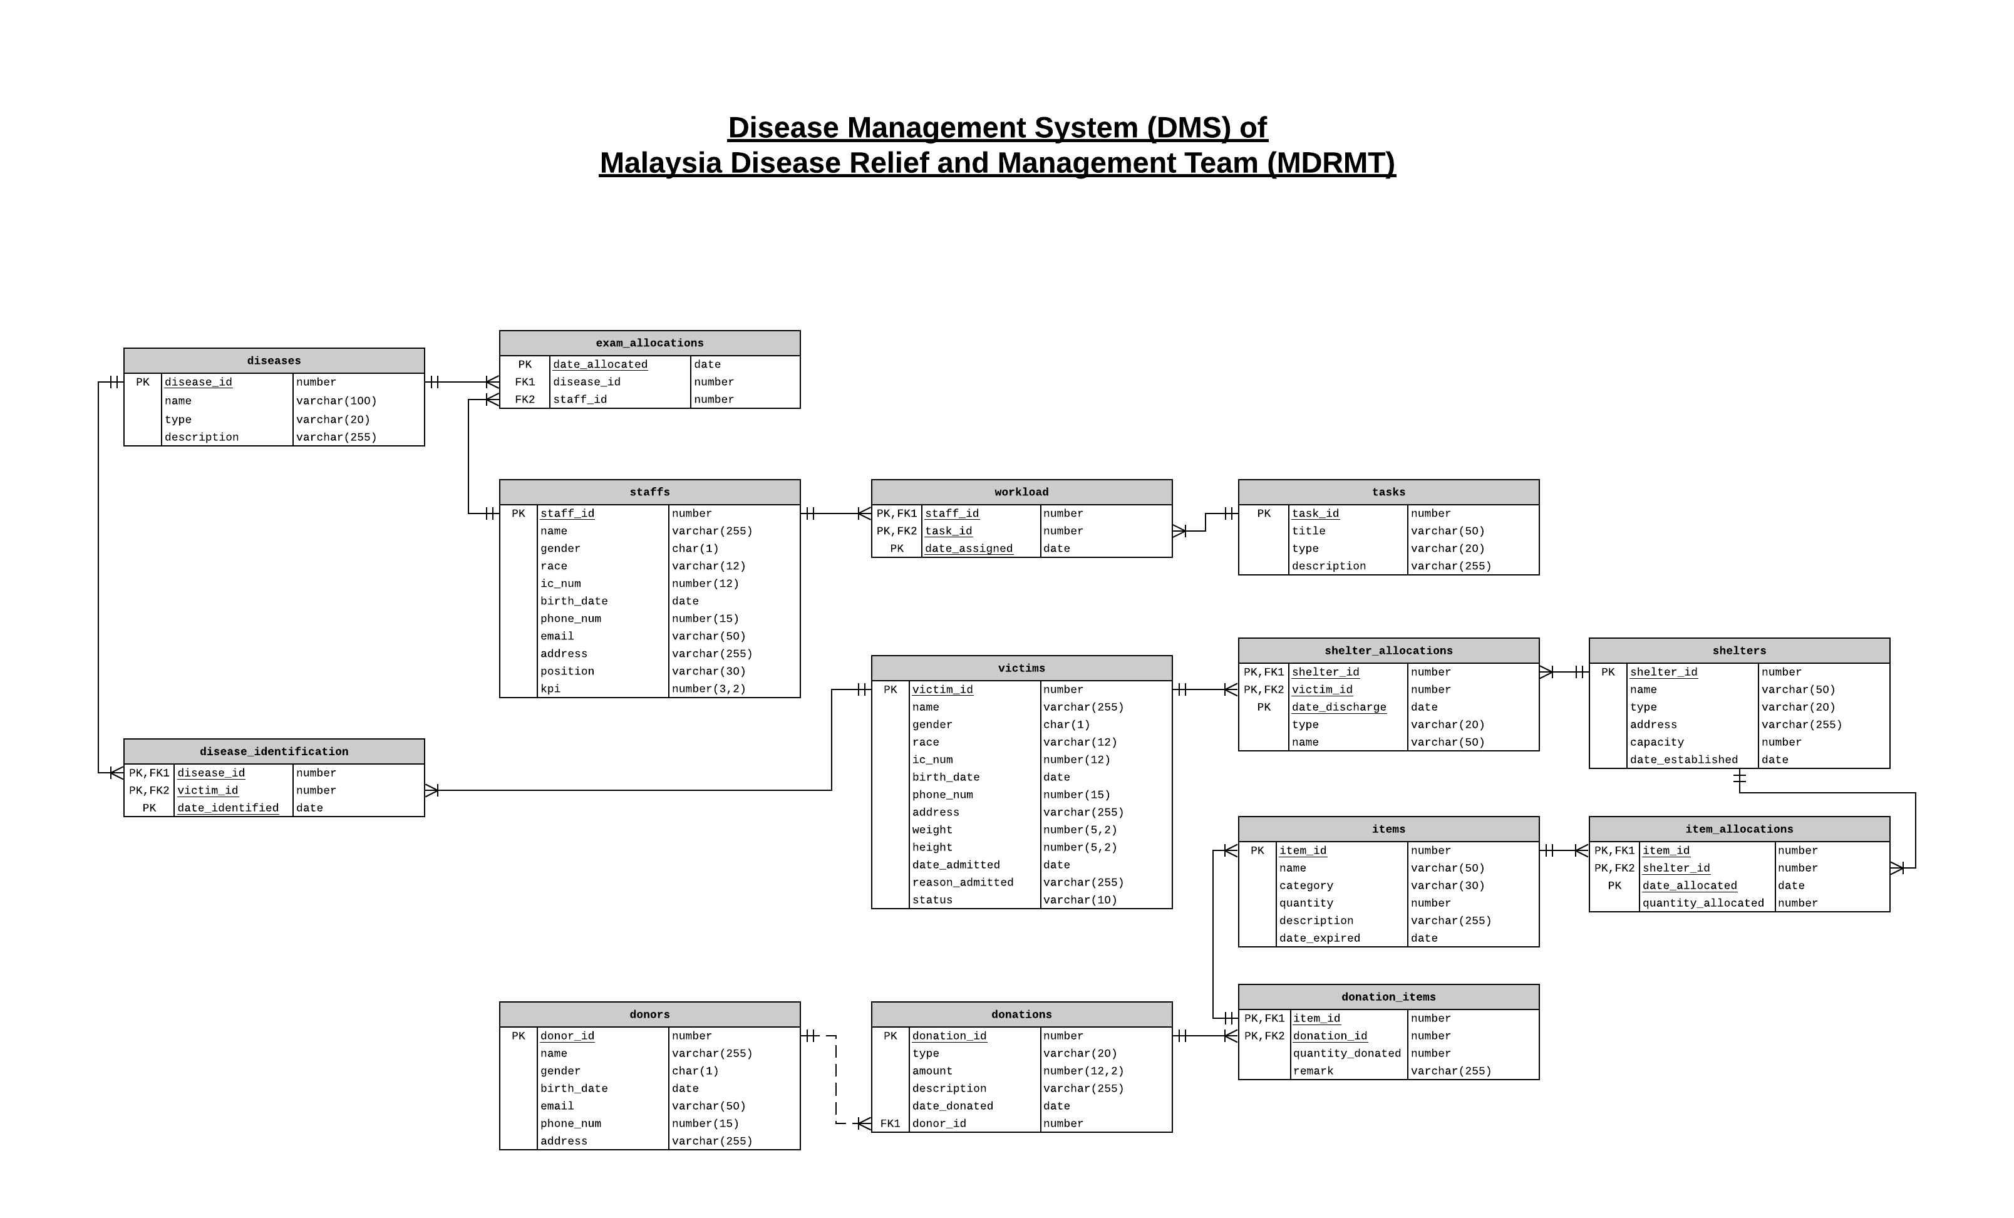https://app.lucidchart.com/invitations/accept/95bacef7-928a-42b5-8e00-9ea6f489e0c4

2.2 Assumptions

- Every shelter must have stand-by staffs at any time.
- The victims admitted to the hospital are able to pay the fees.
- The donors do not expect any reward in return.
- All the items donated are not defect.

Task 3: Normalization

3.1 Attributes of entities with keys

Diseases (disease_id, name, type, description)
Disease_identification (disease_id*, victim_id*, date_identified)
Victims (victim_id, name, gender, race, ic_num, birth_date, phone_num, address, weight, height, date_admitted, reason_admitted, status)
Exam_allocations (date_allocated, disease_id*, staff_id*)
Staffs (staff_id, name, gender, race, ic_num, birth_date, phone_num, email, address, position, kpi)
Workload (staff_id*, task_id*, date_assgined)
Tasks (task_id, title, type, description)
Shelters (shelter_id, name, type, address, capacity, data_established)
Shelter_allocations (shelter_id*, victim_id*, date_discharge, type, name)
Item_allocations (item_id*, shelter_id*, date_allocated, quantity_allocated)
Items (item_id, name, category, quantity, description, date_expired)
Donation_items (item_id*, donation_id*, quantity_donated, remark)
Donations (donatiod_id, type, amount, description, date_donated, donor_id*)
Donors (donor_id, name, gender, birth_date, email, phone_num, address)

Task 4: Create Databases in Oracle

4.1 Diseases table
CREATE TABLE diseases (
disease_id NUMBER, -- PK
name VARCHAR(100) NOT NULL UNIQUE,
type VARCHAR(30),
description VARCHAR(255),
PRIMARY KEY(disease_id)
);

-- Following code is to auto-increment disease_id

-- This sequence is to auto increment the id.
CREATE SEQUENCE disease_id_seq START WITH 1001;

-- Below code is to trigger sequence to increment by 1 when CREATE or REPLACE is detected.
CREATE OR REPLACE TRIGGER disease_id_bir
BEFORE INSERT ON diseases
FOR EACH ROW

BEGIN
SELECT disease_id_seq.NEXTVAL
INTO :new.disease_id
FROM dual;
END;
/

4.2 Victims table
CREATE TABLE victims (
victim_id NUMBER, -- PK
name VARCHAR(255) NOT NULL,
gender CHAR(1) NOT NULL,
race VARCHAR(12) NOT NULL,
ic_num VARCHAR(15) NOT NULL UNIQUE, -- IC Number must be specified and cannot be duplicated
birth_date DATE NOT NULL,
phone_num VARCHAR(15) NOT NULL,
address VARCHAR(255),
weight NUMBER(5,2),
height NUMBER(5,2),
date_admitted DATE DEFAULT SYSDATE, -- Default to current date if not specified
reason_admitted VARCHAR(255),
status VARCHAR(10) DEFAULT 'PENDING', -- Default to PENDING if not specified
PRIMARY KEY(victim_id),
CONSTRAINT chk_victim_gender CHECK (UPPER(gender) in ('M', 'F')),
CONSTRAINT chk_victim_race CHECK (UPPER(race) in ('CHINESE', 'MALAY', 'INDIAN', 'IBAN', 'KADAZANDUSUN', 'OTHERS')),
CONSTRAINT chk_victim_status CHECK (UPPER(status) in ('PENDING', 'RECOVERED', 'SERIOUS', 'DEATH'))
);

-- Following code is to auto-increment victim_id

-- This sequence is to auto increment the id.
CREATE SEQUENCE victim_id_seq START WITH 2001;

-- Below code is to trigger sequence to increment by 1 when CREATE or REPLACE is detected.
CREATE OR REPLACE TRIGGER victim_id_bir
BEFORE INSERT ON victims
FOR EACH ROW

BEGIN
SELECT victim_id_seq.NEXTVAL
INTO :new.victim_id
FROM dual;
END;
/

4.3 Staffs table
CREATE TABLE staffs (
staff_id NUMBER, -- PK
name VARCHAR(255) NOT NULL,
gender CHAR(1) NOT NULL,
race VARCHAR(12) NOT NULL,
ic_num VARCHAR(15) NOT NULL UNIQUE, -- IC Number must be specified and cannot be duplicated
birth_date DATE NOT NULL,
phone_num VARCHAR(15) NOT NULL UNIQUE, -- Phone Number must be specified and cannot be duplicated
email VARCHAR(50) NOT NULL UNIQUE, -- Email must be specified and cannot be duplicated
address VARCHAR(255) NOT NULL,
position VARCHAR(30) NOT NULL,
kpi NUMBER(3,2) DEFAULT 2.00, -- Default to 2.00 if not specified
PRIMARY KEY(staff_id),
CONSTRAINT chk_staff_gender CHECK (UPPER(gender) in ('M', 'F')),
CONSTRAINT chk_staff_race CHECK (UPPER(race) in ('CHINESE', 'MALAY', 'INDIAN', 'IBAN', 'KADAZANDUSUN', 'OTHERS')),
CONSTRAINT chk_staff_email CHECK (REGEXP_LIKE(email,'^[a-zA-Z]\w+@(\S+)$'))
);

-- Following code is to auto-increment staff_id

-- This sequence is to auto increment the id.
CREATE SEQUENCE staff_id_seq START WITH 3001;

-- Below code is to trigger sequence to increment by 1 when CREATE or REPLACE is detected.
CREATE OR REPLACE TRIGGER staff_id_bir
BEFORE INSERT ON staffs
FOR EACH ROW

BEGIN
SELECT staff_id_seq.NEXTVAL
INTO :new.staff_id
FROM dual;
END;
/

4.4 Donors table
CREATE TABLE donors (
donor_id NUMBER, -- PK
name VARCHAR(255) NOT NULL,
gender CHAR(1) NOT NULL,
birth_date DATE NOT NULL,
email VARCHAR(50) NOT NULL UNIQUE, -- Email must be specified and cannot be duplicated
phone_num VARCHAR(15) NOT NULL UNIQUE, -- Phone Number must be specified and cannot be duplicated
address VARCHAR(255) NOT NULL,
PRIMARY KEY(donor_id),
CONSTRAINT chk_donor_gender CHECK (UPPER(gender) in ('M', 'F')),
CONSTRAINT chk_donor_email CHECK (REGEXP_LIKE(email,'^[a-zA-Z]\w+@(\S+)$'))
);

-- Following code is to auto-increment donor_id

-- This sequence is to auto increment the id.
CREATE SEQUENCE donor_id_seq START WITH 4001;

-- Below code is to trigger sequence to increment by 1 when CREATE or REPLACE is detected.
CREATE OR REPLACE TRIGGER donor_id_bir
BEFORE INSERT ON donors
FOR EACH ROW

BEGIN
SELECT donor_id_seq.NEXTVAL
INTO :new.donor_id
FROM dual;
END;
/

4.5 Shelters table
CREATE TABLE shelters (
shelter_id NUMBER, -- PK
name VARCHAR(100) NOT NULL,
type VARCHAR(20) NOT NULL,
address VARCHAR(255) NOT NULL UNIQUE, -- Address cant be duplicated
capacity NUMBER NOT NULL,
date_established DATE NOT NULL,
PRIMARY KEY(shelter_id),
-- CONSTRAINT chk_is_date_established_valid CHECK (date_established <= SYSDATE),
CONSTRAINT chk_shelter_type CHECK (UPPER(type) in ('HOSPITAL', 'CLINIC'))
);

-- Following code is to auto-increment shelter_id

-- This sequence is to auto increment the id.
CREATE SEQUENCE shelter_id_seq START WITH 5001;

-- Below code is to trigger sequence to increment by 1 when CREATE or REPLACE is detected.
CREATE OR REPLACE TRIGGER shelter_id_bir
BEFORE INSERT ON shelters
FOR EACH ROW

BEGIN
SELECT shelter_id_seq.NEXTVAL
INTO :new.shelter_id
FROM dual;
END;
/

4.6 Items table
CREATE TABLE items (
item_id NUMBER,
name VARCHAR(50) NOT NULL UNIQUE, -- The same item cannot be duplicated
category VARCHAR(30) NOT NULL,
quantity NUMBER NOT NULL,
description VARCHAR(255) NOT NULL,
date_expired DATE NOT NULL,
PRIMARY KEY(item_id),
-- CONSTRAINT chk_is_item_expired CHECK (date_expired <= SYSDATE),
CONSTRAINT chk_is_quantity_valid CHECK (quantity > 0)
);

-- Following code is to auto-increment item_id

-- This sequence is to auto increment the id.
CREATE SEQUENCE item_id_seq START WITH 6001;

-- Below code is to trigger sequence to increment by 1 when CREATE or REPLACE is detected.
CREATE OR REPLACE TRIGGER item_id_bir
BEFORE INSERT ON items
FOR EACH ROW

BEGIN
SELECT item_id_seq.NEXTVAL
INTO :new.item_id
FROM dual;
END;
/

4.7 Tasks table
CREATE TABLE tasks (
task_id NUMBER, -- PK
title VARCHAR(50) NOT NULL,
type VARCHAR(20) NOT NULL,
description VARCHAR(255),
PRIMARY KEY(task_id)
);

-- Following code is to auto-increment task_id

-- This sequence is to auto increment the id.
CREATE SEQUENCE task_id_seq START WITH 7001;

-- Below code is to trigger sequence to increment by 1 when CREATE or REPLACE is detected.
CREATE OR REPLACE TRIGGER task_id_bir
BEFORE INSERT ON tasks
FOR EACH ROW

BEGIN
SELECT task_id_seq.NEXTVAL
INTO :new.task_id
FROM dual;
END;
/

4.8 Disease_identifications table
CREATE TABLE disease_identifications (
disease_id NUMBER, -- PK, FK1
victim_id NUMBER, -- PK, FK2
date_identified DATE,
PRIMARY KEY(disease_id, victim_id, date_identified),
CONSTRAINT chk_identifications_diseases
FOREIGN KEY (disease_id)
REFERENCES diseases(disease_id)
ON DELETE CASCADE -- If the disease is deleted, this record is deleted as well
);

4.9 Exam_allocations table
CREATE TABLE exam_allocations (
date_allocated DATE, -- PK
disease_id NUMBER, -- PK, FK1
staff_id NUMBER, -- PK, FK2
PRIMARY KEY(date_allocated, disease_id, staff_id),
CONSTRAINT chk_exam_allocations_diseases
FOREIGN KEY (disease_id)
REFERENCES diseases(disease_id),
CONSTRAINT chk_exam_allocations_staffs
FOREIGN KEY (staff_id)
REFERENCES staffs(staff_id)
ON DELETE CASCADE -- If the staff is deleted, this record is deleted as well
);

4.10 Workload table
CREATE TABLE workload (
staff_id NUMBER, -- PK, FK1
task_id NUMBER, -- PK, FK2
date_assigned DATE, -- PK
PRIMARY KEY(staff_id, task_id, date_assigned),
CONSTRAINT chk_workload_staffs
FOREIGN KEY (staff_id)
REFERENCES staffs(staff_id),
CONSTRAINT chk_workload_tasks
FOREIGN KEY (task_id)
REFERENCES tasks(task_id)
ON DELETE CASCADE -- If the task is deleted, this record is deleted as well
-- CONSTRAINT chk_is_date_assigned_valid CHECK (date_assigned >= SYSDATE)
);

4.11 Donations table
CREATE TABLE donations (
donation_id NUMBER, -- PK
type VARCHAR(20) NOT NULL,
amount NUMBER(12, 2),
description VARCHAR(255),
date_donated DATE DEFAULT SYSDATE, -- Default to current date if not specified
donor_id NUMBER, -- FK1
PRIMARY KEY(donation_id),
CONSTRAINT fk_donations_donors
FOREIGN KEY(donor_id)
REFERENCES donors(donor_id),
CONSTRAINT chk_donation_type CHECK (UPPER(type) in ('MONEY', 'MEDICAL_SUPPLIES'))
);

-- Following code is to auto-increment donation_id

-- This sequence is to auto increment the id.
CREATE SEQUENCE donation_id_seq START WITH 11001;

-- Below code is to trigger sequence to increment by 1 when CREATE or REPLACE is detected.
CREATE OR REPLACE TRIGGER donation_id_bir
BEFORE INSERT ON donations
FOR EACH ROW

BEGIN
SELECT donation_id_seq.NEXTVAL
INTO :new.donation_id
FROM dual;
END;
/

4.12 Donation_items table
CREATE TABLE donation_items (
item_id NUMBER, -- PK, FK1
donation_id NUMBER, -- PK, FK2
quantity_donated NUMBER,
remark VARCHAR(255),
PRIMARY KEY(item_id, donation_id),
CONSTRAINT chk_donation_items_items
FOREIGN KEY (item_id)
REFERENCES items(item_id)
ON DELETE CASCADE, -- If the item is deleted, this record is deleted as well
CONSTRAINT chk_donation_items_donations
FOREIGN KEY (donation_id)
REFERENCES donations(donation_id)
ON DELETE CASCADE -- If the donation is deleted, this record is deleted as well
);

4.13 Shelter_allocations table
CREATE TABLE shelter_allocations (
shelter_id NUMBER, -- PK, FK1
victim_id NUMBER, -- PK, FK2
date_discharge DATE, -- PK
type VARCHAR(40),
name VARCHAR(50),
PRIMARY KEY(shelter_id, victim_id, date_discharge),
CONSTRAINT chk_allocations_shelters
FOREIGN KEY (shelter_id)
REFERENCES shelters(shelter_id)
ON DELETE CASCADE, -- If the shelter is deleted, this record is deleted as well
CONSTRAINT chk_allocations_victims
FOREIGN KEY (victim_id)
REFERENCES victims(victim_id)
ON DELETE CASCADE -- If the victim is deleted, this record is deleted as well
);

4.14 Item_allocations table
CREATE TABLE item_allocations (
item_id NUMBER, -- PK, FK1
shelter_id NUMBER, -- PK, FK2
date_allocated DATE, -- PK
quantity_allocated NUMBER,
PRIMARY KEY(item_id, shelter_id, date_allocated),
CONSTRAINT chk_item_allocations_items
FOREIGN KEY (item_id)
REFERENCES items(item_id)
ON DELETE CASCADE, -- If the item is deleted, this record is deleted as well
CONSTRAINT chk_item_allocations_shelters
FOREIGN KEY (shelter_id)
REFERENCES shelters(shelter_id)
ON DELETE CASCADE, -- If the shelter is deleted, this record is deleted as well
CONSTRAINT chk_is_quantityA_valid CHECK (quantity_allocated > 0)
);

Task 5: Sample Data Records

5.1 Diseases table
INSERT INTO DISEASES (name, type, description) VALUES ('Alzheimer''s Disease', 'Lungs', 'Heart and Great Vessels, Release');
INSERT INTO DISEASES (name, type, description) VALUES ('Dengue Virus (DENV)', 'High Blood Pressure', 'Measurement of Products of Conception, Cardiac Sound, Via Natural or Artificial Opening Endoscopic');
INSERT INTO DISEASES (name, type, description) VALUES ('Human Immunodeficiency Virus (HIV)', 'Heart', 'Drainage of Left Thorax Tendon, Percutaneous Approach, Diagnostic');
INSERT INTO DISEASES (name, type, description) VALUES ('Coronavirus Disease 2019 (COVID-19)', 'Diabetes', 'Drainage of Right Subclavian Vein, Percutaneous Approach, Diagnostic');
INSERT INTO DISEASES (name, type, description) VALUES ('Severe Acute Respiratory Syndrome (SARS)', 'Allergies', 'Fusion of Right Hip Joint with Internal Fixation Device, Percutaneous Endoscopic Approach');
INSERT INTO DISEASES (name, type, description) VALUES ('Middle East Respiratory Syndrome (MERS)', 'Eyesight', 'Repair Right Lower Lobe Bronchus, Via Natural or Artificial Opening Endoscopic');
INSERT INTO DISEASES (name, type, description) VALUES ('Swine Flu (H1N1 Virus)', 'Alzheimer''s', 'Reposition Bladder, Percutaneous Endoscopic Approach');
INSERT INTO DISEASES (name, type, description) VALUES ('Heart Attack', 'High Blood Pressure', 'Introduction of Radioactive Substance into Female Reproductive, Percutaneous Approach');
INSERT INTO DISEASES (name, type, description) VALUES ('Stroke', 'Rheumatoid Arthritis', 'Insertion of Hybrid External Fixation Device into Left Humeral Shaft, Percutaneous Approach');
INSERT INTO DISEASES (name, type, description) VALUES ('Pneumonia', 'Allergies', 'Dilation of Left Foot Artery with Four or More Intraluminal Devices, Open Approach');

5.2 Victims table
INSERT INTO VICTIMS (name, gender, race, ic_num, birth_date, phone_num, address, weight, height, date_admitted, reason_admitted, status) VALUES ('Sylas Farries', 'M', 'Others', '025225-68-6299', '15-Apr-2010', '016-5459373', '89572 Harbort Terrace', 18.82, 183.26, '12-Aug-2013', 'Pois-erythromyc/macrolid', 'Discharged');
INSERT INTO VICTIMS (name, gender, race, ic_num, birth_date, phone_num, address, weight, height, date_admitted, reason_admitted, status) VALUES ('Dermot Nial', 'M', 'Malay', '468217-75-2437', '20-May-1995', '014-7594124', '04 Sherman Center', 33.72, 152.8, '13-Oct-2016', 'Fet distress befor labor', 'Serious');
INSERT INTO VICTIMS (name, gender, race, ic_num, birth_date, phone_num, address, weight, height, date_admitted, reason_admitted, status) VALUES ('Marney Marquis', 'F', 'Malay', '420195-03-5904', '19-Aug-1966', '012-4265703', '24631 Westport Point', 94.15, 169.17, '27-Nov-2014', 'Mumps uncomplicated', 'Discharged');
INSERT INTO VICTIMS (name, gender, race, ic_num, birth_date, phone_num, address, weight, height, date_admitted, reason_admitted, status) VALUES ('Georgine Hadwick', 'F', 'Kadazandusun', '087018-57-7541', '26-Mar-2005', '012-0714170', '4 Southridge Drive', 76.51, 168.61, '17-Aug-2012', 'Placent polyp-del w p/p', 'Serious');
INSERT INTO VICTIMS (name, gender, race, ic_num, birth_date, phone_num, address, weight, height, date_admitted, reason_admitted, status) VALUES ('Ayn Banasik', 'F', 'Chinese', '541019-57-6743', '07-Aug-2003', '011-5012555', '9639 Kings Terrace', 23.94, 103.83, '28-Sep-2014', 'Pulmon TB NOS-oth test', 'Discharged');
INSERT INTO VICTIMS (name, gender, race, ic_num, birth_date, phone_num, address, weight, height, date_admitted, reason_admitted, status) VALUES ('Roland Bedbury', 'M', 'Kadazandusun', '018568-65-7391', '05-Mar-2002', '012-7623029', '85 Anhalt Hill', 93.96, 152.49, '01-Aug-2018', 'Perinat GI sys dis NEC', 'Pending');
INSERT INTO VICTIMS (name, gender, race, ic_num, birth_date, phone_num, address, weight, height, date_admitted, reason_admitted, status) VALUES ('Rosa Featherstonehaugh', 'F', 'Iban', '941258-94-8749', '20-Jun-2008', '012-1676318', '2 Erie Crossing', 12.17, 103.5, '08-Aug-2018', 'Comp reattach extrem NOS', 'Discharged');
INSERT INTO VICTIMS (name, gender, race, ic_num, birth_date, phone_num, address, weight, height, date_admitted, reason_admitted, status) VALUES ('Morgana Kurtis', 'F', 'Iban', '057935-65-3840', '30-Oct-1986', '018-4448270', '58812 Garrison Junction', 50.15, 153.78, '28-Feb-2014', 'Poison-mix sedative NEC', 'Serious');
INSERT INTO VICTIMS (name, gender, race, ic_num, birth_date, phone_num, address, weight, height, date_admitted, reason_admitted, status) VALUES ('Niccolo McCourt', 'M', 'Indian', '337358-67-6175', '08-Feb-2012', '014-6925615', '77 Hallows Center', 23.84, 164.06, '20-Dec-2012', 'Cholesteatoma middle ear', 'Discharged');
INSERT INTO VICTIMS (name, gender, race, ic_num, birth_date, phone_num, address, weight, height, date_admitted, reason_admitted, status) VALUES ('Livy Day', 'F', 'Indian', '370467-62-7031', '29-Jul-1961', '014-1531738', '11 Village Green Plaza', 81.14, 163.55, '10-Aug-2011', 'Pyoderma NEC', 'Pending');

5.3 Staffs table
INSERT INTO STAFFS (name, gender, race, ic_num, birth_date, phone_num, email, address, position, kpi) VALUES ('Tara Balogh', 'F', 'Kadazandusun', '476402-22-7490', '29-Jan-1975', '012-3877870', 'tbalogh0@tripod.com', '08 Dixon Trail', 'Cleaner', 2.14);
INSERT INTO STAFFS (name, gender, race, ic_num, birth_date, phone_num, email, address, position, kpi) VALUES ('Spence Pucknell', 'M', 'Malay', '579694-50-7319', '29-Jul-2014', '010-0412397', 'spucknell1@whitehouse.gov', '9456 5th Court', 'Nurse', 3.68);
INSERT INTO STAFFS (name, gender, race, ic_num, birth_date, phone_num, email, address, position, kpi) VALUES ('Giff Wroath', 'M', 'Iban', '058362-57-1467', '29-Apr-2004', '012-1440787', 'gwroath2@liveinternet.ru', '6 Rigney Lane', 'Cleaner', 3.15);
INSERT INTO STAFFS (name, gender, race, ic_num, birth_date, phone_num, email, address, position, kpi) VALUES ('Truda Cattemull', 'F', 'Others', '908639-59-9602', '13-Jun-1966', '019-9441778', 'tcattemull3@fema.gov', '89 Judy Lane', 'Warehouse Manager', 2.73);
INSERT INTO STAFFS (name, gender, race, ic_num, birth_date, phone_num, email, address, position, kpi) VALUES ('Brucie Kenen', 'M', 'Chinese', '852360-75-0992', '02-Mar-2014', '013-0621282', 'bkenen4@cnet.com', '116 Ridgeview Junction', 'Cleaner', 3.61);
INSERT INTO STAFFS (name, gender, race, ic_num, birth_date, phone_num, email, address, position, kpi) VALUES ('Edy Burdis', 'F', 'Kadazandusun', '542298-24-7800', '20-Sep-2013', '019-8644464', 'eburdis5@sbwire.com', '27873 Laurel Junction', 'Specialist', 3.61);
INSERT INTO STAFFS (name, gender, race, ic_num, birth_date, phone_num, email, address, position, kpi) VALUES ('Barde Sotheby', 'M', 'Others', '809451-48-4156', '05-Oct-1961', '016-4386483', 'bsotheby6@wisc.edu', '8 West Parkway', 'Specialist', 3.44);
INSERT INTO STAFFS (name, gender, race, ic_num, birth_date, phone_num, email, address, position, kpi) VALUES ('Charita Grieg', 'F', 'Others', '864505-11-7635', '26-Oct-2017', '014-3056430', 'cgrieg7@privacy.gov.au', '0 Saint Paul Drive', 'Warehouse Manager', 3.52);
INSERT INTO STAFFS (name, gender, race, ic_num, birth_date, phone_num, email, address, position, kpi) VALUES ('Marlyn Ollie', 'F', 'Others', '801247-34-0501', '07-Nov-1987', '013-5767775', 'mollie8@scientificamerican.com', '326 Fair Oaks Alley', 'Nurse', 2.47);
INSERT INTO STAFFS (name, gender, race, ic_num, birth_date, phone_num, email, address, position, kpi) VALUES ('Drucy Gaythwaite', 'F', 'Malay', '629793-39-1670', '25-Jan-1975', '011-8931386', 'dgaythwaite9@freewebs.com', '072 Fisk Trail', 'Warehouse Manager', 3.89);

5.4 Donors table
INSERT INTO DONORS (name, gender, birth_date, email, phone_num, address) VALUES ('Camilla Messager', 'F', '24-Aug-2014', 'cmessager0@oakley.com', '019-9709991', '81 Bellgrove Court');
INSERT INTO DONORS (name, gender, birth_date, email, phone_num, address) VALUES ('Hazel Coase', 'F', '11-Dec-1991', 'hcoase1@eventbrite.com', '013-0657208', '1124 Saint Paul Place');
INSERT INTO DONORS (name, gender, birth_date, email, phone_num, address) VALUES ('Anetta Lindenfeld', 'F', '31-Mar-1967', 'alindenfeld2@google.pl', '011-3759532', '478 Pierstorff Court');
INSERT INTO DONORS (name, gender, birth_date, email, phone_num, address) VALUES ('Tadeo Twort', 'M', '08-May-2011', 'ttwort3@sakura.ne.jp', '014-3991903', '5 Graceland Park');
INSERT INTO DONORS (name, gender, birth_date, email, phone_num, address) VALUES ('Eudora Sink', 'F', '20-Mar-1976', 'esink4@sitemeter.com', '011-3442047', '2 Saint Paul Crossing');
INSERT INTO DONORS (name, gender, birth_date, email, phone_num, address) VALUES ('Ranna Crowther', 'F', '04-Oct-1979', 'rcrowther5@nature.com', '012-9293131', '21969 Victoria Hill');
INSERT INTO DONORS (name, gender, birth_date, email, phone_num, address) VALUES ('Sampson Whimp', 'M', '17-Mar-2014', 'swhimp6@artisteer.com', '015-6537292', '52 Sheridan Circle');
INSERT INTO DONORS (name, gender, birth_date, email, phone_num, address) VALUES ('Kristal Simionescu', 'F', '04-Jul-1990', 'ksimionescu7@ox.ac.uk', '013-4197120', '6 Meadow Vale Road');
INSERT INTO DONORS (name, gender, birth_date, email, phone_num, address) VALUES ('Tessi Hawkswood', 'F', '22-Dec-1978', 'thawkswood8@taobao.com', '014-1053131', '555 Bunting Street');
INSERT INTO DONORS (name, gender, birth_date, email, phone_num, address) VALUES ('Thane Kuschel', 'M', '24-Oct-1986', 'tkuschel9@canalblog.com', '014-0184504', '8 Delladonna Place');

5.5 Shelters table
INSERT INTO SHELTERS (name, type, address, capacity, date_established) VALUES ('KPJ Sibu Specialist Medical Centre', 'Hospital', '20052 East Alley', 1630, '21-Jan-1972');
INSERT INTO SHELTERS (name, type, address, capacity, date_established) VALUES ('Hospital Lundu', 'Clinic', '65279 Village Green Point', 880, '17-May-1976');
INSERT INTO SHELTERS (name, type, address, capacity, date_established) VALUES ('Hospital Gua Musang', 'Clinic', '93775 Green Crossing', 2997, '10-Sep-1966');
INSERT INTO SHELTERS (name, type, address, capacity, date_established) VALUES ('Hospital Lawas', 'Clinic', '83616 Farwell Terrace', 4634, '28-Nov-1984');
INSERT INTO SHELTERS (name, type, address, capacity, date_established) VALUES ('Pusat Rawatan Islam An-Nisa', 'Clinic', '973 Cherokee Trail', 2298, '07-Oct-2017');
INSERT INTO SHELTERS (name, type, address, capacity, date_established) VALUES ('Hospital Pasir Mas', 'Hospital', '87 Basil Terrace', 620, '22-Dec-1987');
INSERT INTO SHELTERS (name, type, address, capacity, date_established) VALUES ('Andorra Women and Children Hospital', 'Clinic', '7 Northport Road', 1926, '27-Oct-2001');
INSERT INTO SHELTERS (name, type, address, capacity, date_established) VALUES ('Rafflesia Medical Centre', 'Clinic', '2112 Lake View Parkway', 4514, '21-Jun-1973');
INSERT INTO SHELTERS (name, type, address, capacity, date_established) VALUES ('Hospital Rehabilitasi Cheras', 'Hospital', '7 Sundown Drive', 4972, '22-Feb-1981');
INSERT INTO SHELTERS (name, type, address, capacity, date_established) VALUES ('Island Hospital', 'Clinic', '45 Mccormick Point', 557, '01-Jan-1965');

5.6 Items table
INSERT INTO ITEMS (name, category, quantity, description, date_expired) VALUES ('Blood bag', 'Treatment Equipment', 520, 'Choroid plexectomy', '30-Aug-2046');
INSERT INTO ITEMS (name, category, quantity, description, date_expired) VALUES ('Braces', 'Diagnostic Equipment', 127, 'Laparoscopy', '14-May-2028');
INSERT INTO ITEMS (name, category, quantity, description, date_expired) VALUES ('Rubber gloves', 'Treatment Equipment', 198, 'Facial bone biopsy', '05-Mar-2022');
INSERT INTO ITEMS (name, category, quantity, description, date_expired) VALUES ('Ambulance', 'Medical Laboratory Equipment', 29, 'Remov mediastinal drain', '27-Sep-2033');
INSERT INTO ITEMS (name, category, quantity, description, date_expired) VALUES ('First aid kit', 'Diagnostic Equipment', 125, 'Toxicology-eye', '22-Dec-2033');
INSERT INTO ITEMS (name, category, quantity, description, date_expired) VALUES ('Microscope', 'Durable Medical Equipment', 170, 'Opn abltn liver les/tiss', '07-Sep-2028');
INSERT INTO ITEMS (name, category, quantity, description, date_expired) VALUES ('Crutch', 'Treatment Equipment', 271, 'Cholera vaccination', '26-Oct-2033');
INSERT INTO ITEMS (name, category, quantity, description, date_expired) VALUES ('Walker', 'Diagnostic Equipment', 391, 'Debridement of nail', '26-Jul-2047');
INSERT INTO ITEMS (name, category, quantity, description, date_expired) VALUES ('Manual Wheelchair', 'Diagnostic Equipment', 48, 'Skull plate removal', '05-Oct-2049');
INSERT INTO ITEMS (name, category, quantity, description, date_expired) VALUES ('Electric Wheelchair', 'Diagnostic Equipment', 528, 'Open valvuloplasty NOS', '03-Oct-2034');

5.7 Tasks table
INSERT INTO TASKS (title, type, description) VALUES ('fusce consequat nulla nisl', 'Administrative', 'mattis pulvinar nulla pede ullamcorper augue a suscipit nulla elit ac nulla sed vel enim sit amet nunc viverra dapibus');
INSERT INTO TASKS (title, type, description) VALUES ('sapien arcu sed augue', 'Administrative', 'felis sed interdum venenatis turpis enim blandit mi in porttitor');
INSERT INTO TASKS (title, type, description) VALUES ('a libero nam dui proin', 'Consultation', 'vitae consectetuer eget rutrum at lorem integer tincidunt ante vel ipsum');
INSERT INTO TASKS (title, type, description) VALUES ('ullamcorper purus sit amet', 'Cleaning', 'massa tempor convallis nulla neque libero convallis eget eleifend luctus ultricies eu nibh quisque id');
INSERT INTO TASKS (title, type, description) VALUES ('sit amet lobortis sapien', 'Cleaning', 'dui vel nisl duis ac nibh fusce lacus purus aliquet at feugiat non pretium quis lectus suspendisse');
INSERT INTO TASKS (title, type, description) VALUES ('dui nec nisi volutpat', 'Meeting', 'potenti cras in purus eu magna vulputate luctus cum sociis natoque penatibus et magnis dis parturient montes');
INSERT INTO TASKS (title, type, description) VALUES ('morbi quis tortor id nulla', 'Medical-Checkups', 'neque aenean auctor gravida sem praesent id massa id nisl venenatis lacinia aenean sit amet justo');
INSERT INTO TASKS (title, type, description) VALUES ('vestibulum velit id pretium iaculis', 'Meeting', 'eget rutrum at lorem integer tincidunt ante vel ipsum praesent');
INSERT INTO TASKS (title, type, description) VALUES ('sapien iaculis congue vivamus metus', 'Administrative', 'aliquam convallis nunc proin at turpis a pede posuere nonummy integer non velit donec diam neque vestibulum');
INSERT INTO TASKS (title, type, description) VALUES ('feugiat et eros vestibulum ac', 'Meeting', 'nulla tellus in sagittis dui vel nisl duis ac nibh fusce lacus purus aliquet at feugiat non pretium quis lectus');

5.8 Disease_identifications table
INSERT INTO DISEASE_IDENTIFICATIONS (disease_id, victim_id, date_identified) VALUES (1712, 2098, '10-Feb-2019');
INSERT INTO DISEASE_IDENTIFICATIONS (disease_id, victim_id, date_identified) VALUES (1220, 2099, '31-May-2020');
INSERT INTO DISEASE_IDENTIFICATIONS (disease_id, victim_id, date_identified) VALUES (1944, 2394, '05-Dec-2019');
INSERT INTO DISEASE_IDENTIFICATIONS (disease_id, victim_id, date_identified) VALUES (1632, 2431, '31-Mar-2017');
INSERT INTO DISEASE_IDENTIFICATIONS (disease_id, victim_id, date_identified) VALUES (1575, 2645, '21-Feb-2020');
INSERT INTO DISEASE_IDENTIFICATIONS (disease_id, victim_id, date_identified) VALUES (1444, 2371, '20-Dec-2012');
INSERT INTO DISEASE_IDENTIFICATIONS (disease_id, victim_id, date_identified) VALUES (1594, 2751, '21-Apr-2019');
INSERT INTO DISEASE_IDENTIFICATIONS (disease_id, victim_id, date_identified) VALUES (1344, 2726, '10-Dec-2013');
INSERT INTO DISEASE_IDENTIFICATIONS (disease_id, victim_id, date_identified) VALUES (1962, 2436, '24-Dec-2015');
INSERT INTO DISEASE_IDENTIFICATIONS (disease_id, victim_id, date_identified) VALUES (1502, 2500, '22-May-2013');

5.9 Exam_allocations table
INSERT INTO EXAM_ALLOCATIONS (date_allocated, disease_id, staff_id) VALUES ('13-Feb-2012', 1172, 3196);
INSERT INTO EXAM_ALLOCATIONS (date_allocated, disease_id, staff_id) VALUES ('26-Dec-2016', 1580, 3481);
INSERT INTO EXAM_ALLOCATIONS (date_allocated, disease_id, staff_id) VALUES ('18-Feb-2014', 1450, 3152);
INSERT INTO EXAM_ALLOCATIONS (date_allocated, disease_id, staff_id) VALUES ('25-Apr-2020', 1202, 3614);
INSERT INTO EXAM_ALLOCATIONS (date_allocated, disease_id, staff_id) VALUES ('04-Mar-2012', 1666, 3616);
INSERT INTO EXAM_ALLOCATIONS (date_allocated, disease_id, staff_id) VALUES ('02-Nov-2014', 1039, 3719);
INSERT INTO EXAM_ALLOCATIONS (date_allocated, disease_id, staff_id) VALUES ('20-Dec-2011', 1296, 3231);
INSERT INTO EXAM_ALLOCATIONS (date_allocated, disease_id, staff_id) VALUES ('21-Mar-2014', 1921, 3728);
INSERT INTO EXAM_ALLOCATIONS (date_allocated, disease_id, staff_id) VALUES ('24-Oct-2012', 1712, 3357);
INSERT INTO EXAM_ALLOCATIONS (date_allocated, disease_id, staff_id) VALUES ('23-Jan-2014', 1651, 3545);

5.10 Workload table
INSERT INTO WORKLOAD (staff_id, task_id, date_assigned) VALUES (3321, 7383, '14-Feb-2012');
INSERT INTO WORKLOAD (staff_id, task_id, date_assigned) VALUES (3683, 7378, '14-Sep-2015');
INSERT INTO WORKLOAD (staff_id, task_id, date_assigned) VALUES (3210, 7578, '07-Oct-2013');
INSERT INTO WORKLOAD (staff_id, task_id, date_assigned) VALUES (3342, 7067, '19-Jan-2017');
INSERT INTO WORKLOAD (staff_id, task_id, date_assigned) VALUES (3281, 7228, '12-Oct-2015');
INSERT INTO WORKLOAD (staff_id, task_id, date_assigned) VALUES (3261, 7902, '13-Jun-2015');
INSERT INTO WORKLOAD (staff_id, task_id, date_assigned) VALUES (3059, 7821, '02-Aug-2014');
INSERT INTO WORKLOAD (staff_id, task_id, date_assigned) VALUES (3850, 7816, '19-Mar-2014');
INSERT INTO WORKLOAD (staff_id, task_id, date_assigned) VALUES (3093, 7538, '06-Jan-2015');
INSERT INTO WORKLOAD (staff_id, task_id, date_assigned) VALUES (3613, 7982, '14-Apr-2015');

5.11 Donations table
INSERT INTO DONATIONS (type, amount, description, date_donated, donor_id) VALUES ('Money', 50786.23, 'aliquam quis turpis eget elit sodales scelerisque mauris sit amet eros', '21-Nov-2016', 4327);
INSERT INTO DONATIONS (type, amount, description, date_donated, donor_id) VALUES ('Money', 18045.58, 'aliquam convallis nunc proin at turpis a pede posuere nonummy integer non velit donec diam neque vestibulum eget', '02-Jun-2020', 4808);
INSERT INTO DONATIONS (type, amount, description, date_donated, donor_id) VALUES ('Money', 70908.92, 'non velit donec diam neque vestibulum eget vulputate ut ultrices vel augue vestibulum', '25-Jul-2017', 4713);
INSERT INTO DONATIONS (type, amount, description, date_donated, donor_id) VALUES ('Medical_supplies', 0, 'dui vel nisl duis ac nibh fusce lacus purus aliquet at feugiat non pretium quis lectus suspendisse potenti in eleifend', '01-Feb-2011', 4662);
INSERT INTO DONATIONS (type, amount, description, date_donated, donor_id) VALUES ('Money', 1000.08, 'pellentesque at nulla suspendisse potenti cras in purus eu magna vulputate luctus cum sociis natoque penatibus et magnis dis parturient', '', 4814);
INSERT INTO DONATIONS (type, amount, description, date_donated, donor_id) VALUES ('Money', 26054.28, 'nascetur ridiculus mus etiam vel augue vestibulum rutrum rutrum neque aenean auctor gravida sem', '26-Feb-2014', 4682);
INSERT INTO DONATIONS (type, amount, description, date_donated, donor_id) VALUES ('Money', 17533.41, 'sapien iaculis congue vivamus metus arcu adipiscing molestie hendrerit at vulputate vitae nisl aenean lectus pellentesque eget', '13-Jun-2019', 4937);
INSERT INTO DONATIONS (type, amount, description, date_donated, donor_id) VALUES ('Money', 2356.27, 'duis bibendum felis sed interdum venenatis turpis enim blandit mi in porttitor pede justo eu', '', 4143);
INSERT INTO DONATIONS (type, amount, description, date_donated, donor_id) VALUES ('Medical_supplies', 0, 'volutpat sapien arcu sed augue aliquam erat volutpat in congue etiam justo etiam pretium iaculis justo in', '01-Jan-2019', 4688);
INSERT INTO DONATIONS (type, amount, description, date_donated, donor_id) VALUES ('Medical_supplies', 0, 'ultrices posuere cubilia curae donec pharetra magna vestibulum aliquet ultrices erat', '02-Dec-2019', 4869);

5.12 Donation_items table
INSERT INTO DONATION_ITEMS (item_id, donation_id, quantity_donated, remark) VALUES (6045, 11041, 556, 'eu massa donec dapibus duis at velit eu est congue elementum in hac habitasse platea');
INSERT INTO DONATION_ITEMS (item_id, donation_id, quantity_donated, remark) VALUES (6068, 11180, 156, 'enim in tempor turpis nec euismod scelerisque quam turpis adipiscing lorem vitae mattis nibh ligula nec sem duis aliquam');
INSERT INTO DONATION_ITEMS (item_id, donation_id, quantity_donated, remark) VALUES (6032, 11866, 460, 'nulla nisl nunc nisl duis bibendum felis sed interdum venenatis turpis enim blandit mi');
INSERT INTO DONATION_ITEMS (item_id, donation_id, quantity_donated, remark) VALUES (6057, 11028, 654, 'nulla tempus vivamus in felis eu sapien cursus vestibulum proin eu mi nulla ac enim in tempor turpis nec');
INSERT INTO DONATION_ITEMS (item_id, donation_id, quantity_donated, remark) VALUES (6038, 11596, 966, 'urna pretium nisl ut volutpat sapien arcu sed augue aliquam erat volutpat');
INSERT INTO DONATION_ITEMS (item_id, donation_id, quantity_donated, remark) VALUES (6040, 11478, 619, 'sit amet lobortis sapien sapien non mi integer ac neque duis bibendum morbi non quam nec dui');
INSERT INTO DONATION_ITEMS (item_id, donation_id, quantity_donated, remark) VALUES (6055, 11727, 910, 'nec euismod scelerisque quam turpis adipiscing lorem vitae mattis nibh ligula nec sem duis aliquam convallis nunc proin');
INSERT INTO DONATION_ITEMS (item_id, donation_id, quantity_donated, remark) VALUES (6003, 11806, 796, 'nullam sit amet turpis elementum ligula vehicula consequat morbi a ipsum integer a nibh');
INSERT INTO DONATION_ITEMS (item_id, donation_id, quantity_donated, remark) VALUES (6014, 11556, 765, 'viverra eget congue eget semper rutrum nulla nunc purus phasellus in felis donec semper sapien a libero nam');
INSERT INTO DONATION_ITEMS (item_id, donation_id, quantity_donated, remark) VALUES (6022, 11972, 603, 'sagittis nam congue risus semper porta volutpat quam pede lobortis ligula');

5.13 Shelter_allocations table
INSERT INTO SHELTER_ALLOCATIONS (shelter_id, victim_id, date_discharge, type, name) VALUES (5459, 2732, '13-Jan-2018', 'leo pellentesque ultrices', 'congue eget semper');
INSERT INTO SHELTER_ALLOCATIONS (shelter_id, victim_id, date_discharge, type, name) VALUES (5392, 2417, '04-Dec-2017', 'tellus', 'sed interdum venenatis turpis enim');
INSERT INTO SHELTER_ALLOCATIONS (shelter_id, victim_id, date_discharge, type, name) VALUES (5441, 2589, '28-Oct-2018', 'neque duis', 'pede venenatis non sodales');
INSERT INTO SHELTER_ALLOCATIONS (shelter_id, victim_id, date_discharge, type, name) VALUES (5537, 2710, '27-Apr-2011', 'suspendisse', 'posuere nonummy integer non velit');
INSERT INTO SHELTER_ALLOCATIONS (shelter_id, victim_id, date_discharge, type, name) VALUES (5854, 2556, '08-Oct-2016', 'nunc donec quis', 'suspendisse potenti nullam porttitor');
INSERT INTO SHELTER_ALLOCATIONS (shelter_id, victim_id, date_discharge, type, name) VALUES (5658, 2037, '12-Nov-2014', 'lobortis', 'donec semper sapien a libero');
INSERT INTO SHELTER_ALLOCATIONS (shelter_id, victim_id, date_discharge, type, name) VALUES (5854, 2495, '24-May-2014', 'dapibus dolor', 'cras in purus');
INSERT INTO SHELTER_ALLOCATIONS (shelter_id, victim_id, date_discharge, type, name) VALUES (5611, 2280, '13-Nov-2017', 'et', 'nisi volutpat eleifend');
INSERT INTO SHELTER_ALLOCATIONS (shelter_id, victim_id, date_discharge, type, name) VALUES (5888, 2648, '27-Mar-2018', 'dis parturient montes', 'posuere cubilia curae nulla');
INSERT INTO SHELTER_ALLOCATIONS (shelter_id, victim_id, date_discharge, type, name) VALUES (5799, 2680, '03-Oct-2018', 'vestibulum sed', 'sapien in sapien iaculis');

5.14 Item_allocations table
INSERT INTO ITEM_ALLOCATIONS (item_id, shelter_id, date_allocated, quantity_allocated) VALUES (6048, 5446, '21-Aug-2012', 864);
INSERT INTO ITEM_ALLOCATIONS (item_id, shelter_id, date_allocated, quantity_allocated) VALUES (6034, 5588, '08-Dec-2017', 63);
INSERT INTO ITEM_ALLOCATIONS (item_id, shelter_id, date_allocated, quantity_allocated) VALUES (6037, 5096, '18-May-2014', 132);
INSERT INTO ITEM_ALLOCATIONS (item_id, shelter_id, date_allocated, quantity_allocated) VALUES (6038, 5209, '07-Aug-2011', 47);
INSERT INTO ITEM_ALLOCATIONS (item_id, shelter_id, date_allocated, quantity_allocated) VALUES (6016, 5897, '11-May-2016', 904);
INSERT INTO ITEM_ALLOCATIONS (item_id, shelter_id, date_allocated, quantity_allocated) VALUES (6064, 5936, '06-Nov-2010', 380);
INSERT INTO ITEM_ALLOCATIONS (item_id, shelter_id, date_allocated, quantity_allocated) VALUES (6009, 5910, '29-Jan-2016', 36);
INSERT INTO ITEM_ALLOCATIONS (item_id, shelter_id, date_allocated, quantity_allocated) VALUES (6018, 5369, '22-Feb-2015', 186);
INSERT INTO ITEM_ALLOCATIONS (item_id, shelter_id, date_allocated, quantity_allocated) VALUES (6013, 5515, '10-Apr-2017', 936);
INSERT INTO ITEM_ALLOCATIONS (item_id, shelter_id, date_allocated, quantity_allocated) VALUES (6068, 5693, '28-Feb-2016', 67);
Task 6: SQL Queries and Reports

6.1 Lee Kai Yang
6.1.1 Query 1: Staffs Workload Count
Purpose: Check workload for staffs according to their position.

SQL statement:
-- Settings for SQL Plus
SET LINESIZE 120
SET PAGESIZE 50
ALTER SESSION SET NLS_DATE_FORMAT = 'DD-MON-YYYY';

-- Setting current time
SET TERMOUT OFF
BREAK ON TODAY
COLUMN TODAY NEW_VALUE _DATE
SELECT TO_CHAR(SYSDATE, 'fmMonth DD, YYYY') TODAY
FROM DUAL;
CLEAR BREAKS
SET TERMOUT ON
SET VERIFY OFF

--------------------------- QUERY 1 -------------------------------

-- Taking User Input
PROMPT QUERY 1 - Check workload for staffs according to their position.
PROMPT
PROMPT Available Positions: [Cleaner, Doctor, Warehouse Manager, Specialist, Nurse, IT Support]
PROMPT
ACCEPT v_position CHAR FORMAT A30 PROMPT 'Enter the Staff Position(in lowercase): '

-- Setting the Titles
TTITLE CENTER '========================================================================================================================' SKIP 2 -
CENTER '---------------------------------------' SKIP 1 -
CENTER '--- Disease Management System (DMS) ---' SKIP 1 -
CENTER '---------------------------------------' SKIP 2 -
CENTER '------------------------------------------------------------------------------------------------------------------------' SKIP 1 -
LEFT '--- ' _DATE CENTER 'Check Workload of Staff based on &v_position' RIGHT 'PAGE: ' SQL.PNO ' ---' SKIP 1 -
CENTER '------------------------------------------------------------------------------------------------------------------------' SKIP 2
BTITLE '' SKIP 1 -
CENTER 'Malaysia Disease Relief and Management Team (MDRMT)' SKIP 2 -
CENTER '========================================================================================================================'

-- Formatting the Result
COLUMN staff_id FORMAT 9999 HEADING "Staff ID" JUSTIFY CENTER
COLUMN name FORMAT A25 HEADING "Doctor Name" JUSTIFY CENTER
COLUMN WorkloadCount FORMAT 99 HEADING "Number of Workload" JUSTIFY CENTER
BREAK ON WorkloadCount

-- Query 1 - Check workload for each position
SELECT COUNT(W.task_id) AS WorkloadCount, S.name, S.staff_id
FROM Staffs S, Workload W
WHERE S.staff_id = W.staff_id
AND LOWER(S.position) = '&v_position'
GROUP BY S.staff_id, S.name, S.position
ORDER BY WorkloadCount DESC;

CLEAR COLUMNS
TTITLE OFF
BTITLE OFF

Sample output:
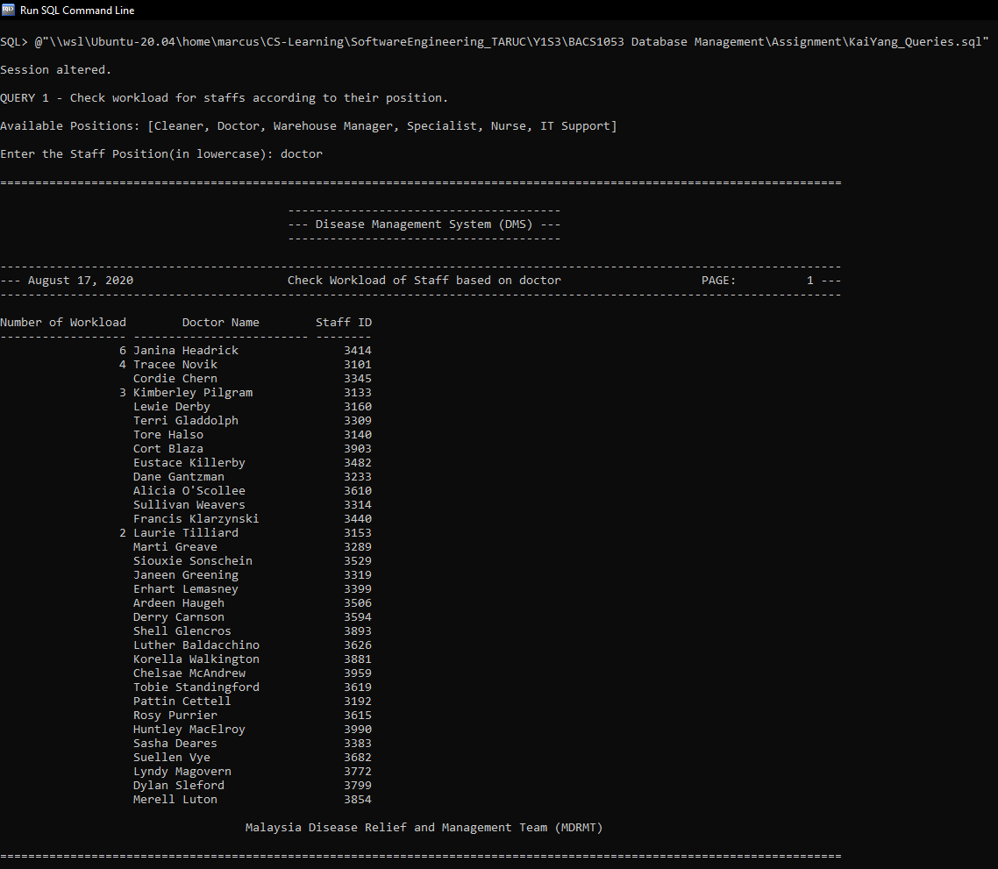
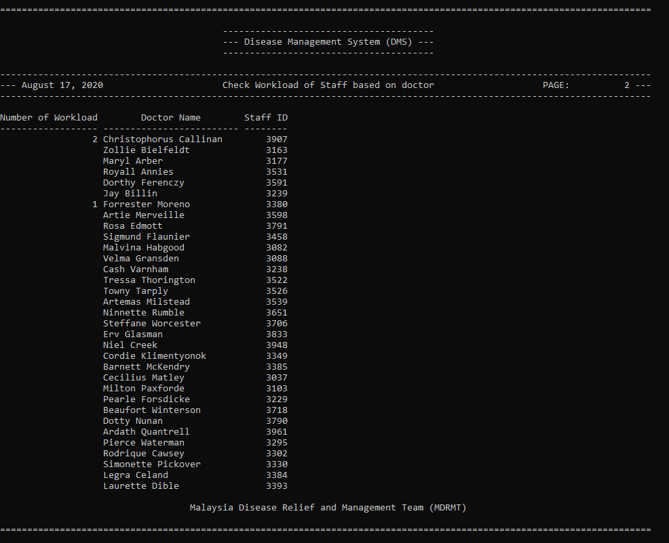

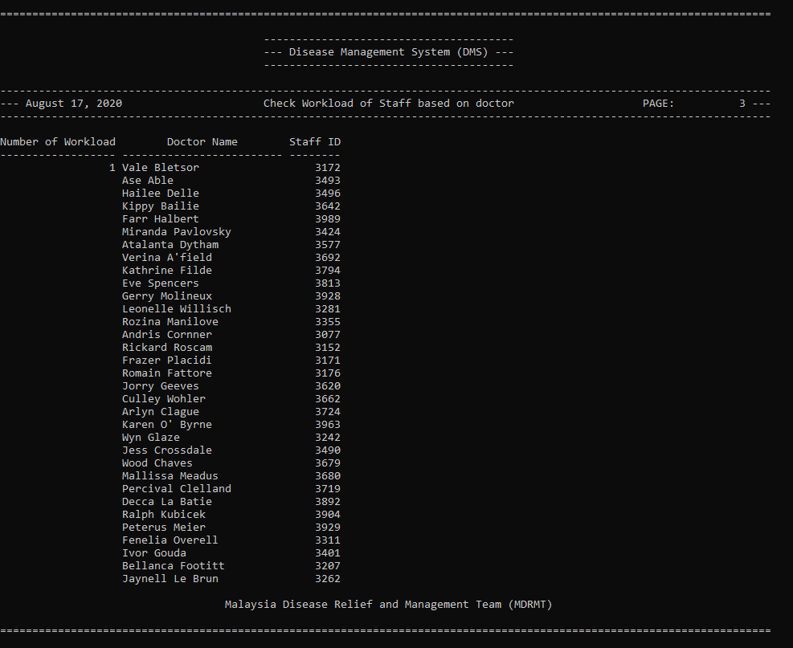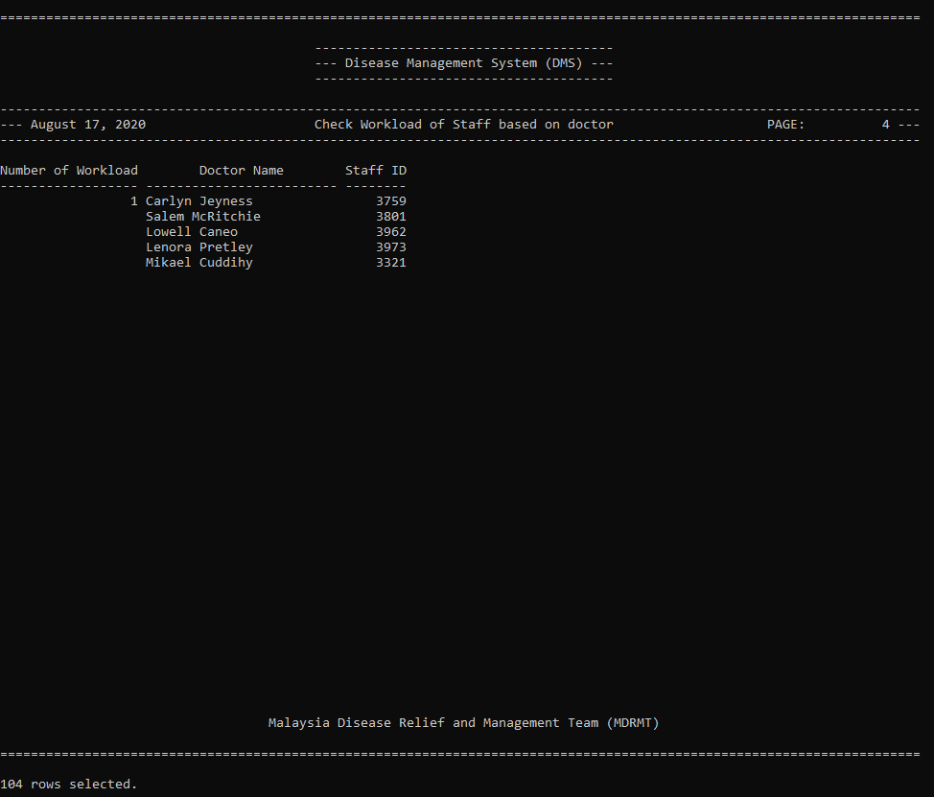

6.1.2 Query 2: Victims Details
Purpose: Check Number of COVID Victims more than average from each hospital where age lesser than user specified age.

SQL statement:
-- Settings for SQL Plus
SET LINESIZE 120
SET PAGESIZE 50
ALTER SESSION SET NLS_DATE_FORMAT = 'DD-MON-YYYY';

-- Setting current time
SET TERMOUT OFF
BREAK ON TODAY
COLUMN TODAY NEW_VALUE _DATE
SELECT TO_CHAR(SYSDATE, 'fmMonth DD, YYYY') TODAY
FROM DUAL;
CLEAR BREAKS
SET TERMOUT ON
SET VERIFY OFF

---------------------------- QUERY 2 -------------------------------
-- Taking User Input
PROMPT QUERY 2 - Check Number of COVID Victims more than average from each hospital where age lesser than user specified age.
PROMPT
PROMPT Available Diseases: [HIV, SARS, MERS, COVID-19, DENV]
PROMPT
ACCEPT v_disease CHAR FORMAT A30 PROMPT 'Enter the Disease: '
ACCEPT v_age NUMBER FORMAT 99 PROMPT 'Enter the Age: '

-- Setting the Titles
TTITLE CENTER '========================================================================================================================' SKIP 2 -
CENTER '---------------------------------------' SKIP 1 -
CENTER '--- Disease Management System (DMS) ---' SKIP 1 -
CENTER '---------------------------------------' SKIP 2 -
CENTER '------------------------------------------------------------------------------------------------------------------------' SKIP 1 -
LEFT '--- ' _DATE CENTER 'Check No of COVID Victims more than average where age lesser than &v_age' RIGHT 'PAGE: ' SQL.PNO ' ---' SKIP 1 -
CENTER '------------------------------------------------------------------------------------------------------------------------' SKIP 2
BTITLE '' SKIP 1 -
CENTER 'Malaysia Disease Relief and Management Team (MDRMT)' SKIP 2 -
CENTER '========================================================================================================================'

-- Formatting the Result
COLUMN DiseaseName FORMAT A35 HEADING "Disease Name" JUSTIFY CENTER
COLUMN name FORMAT A40 HEADING "Hospital Name" JUSTIFY CENTER
COLUMN NoOfCOVIDVictims FORMAT 9999 HEADING "Number of COVID-19 Victims" JUSTIFY CENTER
BREAK ON DiseaseName

-- Query 2 - Check Number of COVID Victims more than average from each hospital where age lesser than age specified by user
SELECT D.name AS DiseaseName, S.name, COUNT(V.victim_id) AS NoOfCOVIDVictims
FROM Victims V, Shelter_allocations SA, Shelters S, Disease_identifications DI, Diseases D
WHERE V.victim_id = SA.victim_id AND SA.shelter_id = S.shelter_id
AND D.disease_id = DI.disease_id AND DI.victim_id = V.victim_id AND (SELECT TRUNC((SYSDATE - TO_DATE(V.birth_date, 'DD-MON-YYYY'))/365.25)
FROM DUAL) < &v_age
AND (SELECT COUNT(victim_id)
FROM victims) > (SELECT AVG(VictimsCount)
FROM (SELECT V.victim_id, COUNT(V.victim_id) AS VictimsCount
FROM Victims V, Disease_identifications DI, Diseases D
WHERE V.victim_id = DI.victim_id AND D.disease_id = DI.disease_id
GROUP BY V.victim_id))
AND D.name LIKE '%&v_disease%'
GROUP BY D.name, S.name
ORDER BY NoOfCOVIDVictims DESC;

CLEAR COLUMNS
TTITLE OFF
BTITLE OFF

Sample output:
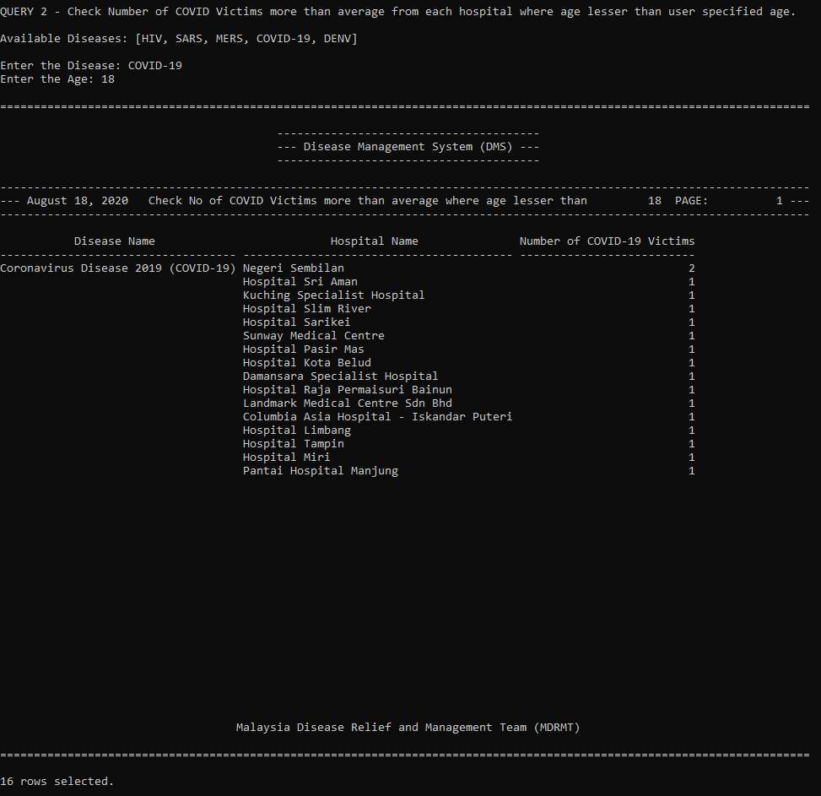
6.1.3 Query 3: Victims Status Count
Purpose: Check victims details for a given shelter between user defined date.

SQL statement:
-- Settings for SQL Plus
SET LINESIZE 120
SET PAGESIZE 50
ALTER SESSION SET NLS_DATE_FORMAT = 'DD-MON-YYYY';

-- Setting current time
SET TERMOUT OFF
BREAK ON TODAY
COLUMN TODAY NEW_VALUE _DATE
SELECT TO_CHAR(SYSDATE, 'fmMonth DD, YYYY') TODAY
FROM DUAL;
CLEAR BREAKS
SET TERMOUT ON
SET VERIFY OFF

-------------------------------------- QUERY 4 -----------------------------------------

-- Taking User Input
PROMPT QUERY 4 - Check victims details for a given shelter between user defined date.
PROMPT
PROMPT Available Status: [PENDING, RECOVERED, SERIOUS, DEATH]
PROMPT Available Shelters: [Beacon Hospital, Salam Medical Centre, Hospital Marudi, Hospital Pasir Mas, ...]
PROMPT (leave blank if all shelters are needed)
PROMPT
PROMPT Example Start/End Date: 01-MAR-2017
PROMPT
ACCEPT v_start_date CHAR FORMAT A30 PROMPT 'Enter the Start Date: '
ACCEPT v_end_date CHAR FORMAT A30 PROMPT 'Enter the End Date: '
ACCEPT v_hospital CHAR FORMAT A50 PROMPT 'Enter the Hospital Name(in lowercase): '
ACCEPT v_status CHAR FORMAT A50 PROMPT 'Enter the status(in lowercase): '

-- Setting the Titles
TTITLE CENTER '========================================================================================================================' SKIP 2 -
CENTER '---------------------------------------' SKIP 1 -
CENTER '--- Disease Management System (DMS) ---' SKIP 1 -
CENTER '---------------------------------------' SKIP 2 -
CENTER '------------------------------------------------------------------------------------------------------------------------' SKIP 1 -
LEFT '--- ' _DATE CENTER 'Check victims details for a given shelter between &v_start_date and &v_end_date' RIGHT 'PAGE: ' SQL.PNO ' ---' SKIP 1 -
CENTER '------------------------------------------------------------------------------------------------------------------------' SKIP 2
BTITLE '' SKIP 1 -
CENTER 'Malaysia Disease Relief and Management Team (MDRMT)' SKIP 2 -
CENTER '========================================================================================================================'

-- Formatting the Result
COLUMN status FORMAT A20 HEADING "Victim Status" JUSTIFY CENTER
COLUMN name FORMAT A50 HEADING "Shelter Name" JUSTIFY CENTER
COLUMN VictimsCount FORMAT 9999 HEADING "Total number of &v_status victims" JUSTIFY CENTER
BREAK ON status

-- Query 4 - Check how many victims are still pending for their disease identification for a given hospital in the past 7 days.
SELECT V.status, S.name, COUNT(SA.victim_id) AS VictimsCount
FROM Shelters S, Shelter_allocations SA, Victims V
WHERE S.shelter_id = SA.shelter_id AND SA.victim_id = V.victim_id
AND V.date_admitted BETWEEN TO_DATE('&v_start_date', 'DD-MON-YYYY') AND TO_DATE('&v_end_date', 'DD-MON-YYYY')
AND LOWER(V.status) LIKE '&v_status'
AND LOWER(S.name) LIKE '%&v_hospital%'
GROUP BY V.status, S.name
ORDER BY VictimsCount DESC;

CLEAR COLUMNS
TTITLE OFF
BTITLE OFF

Sample output:
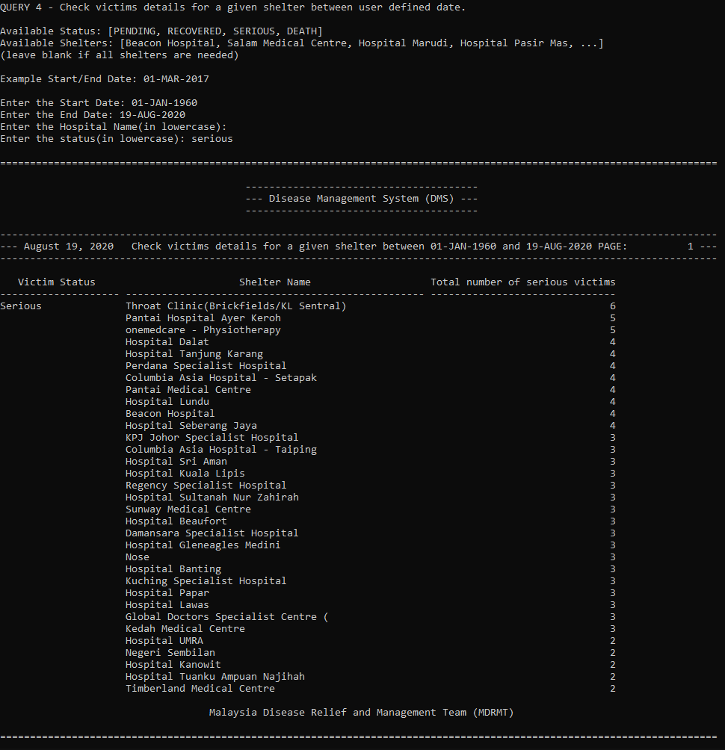
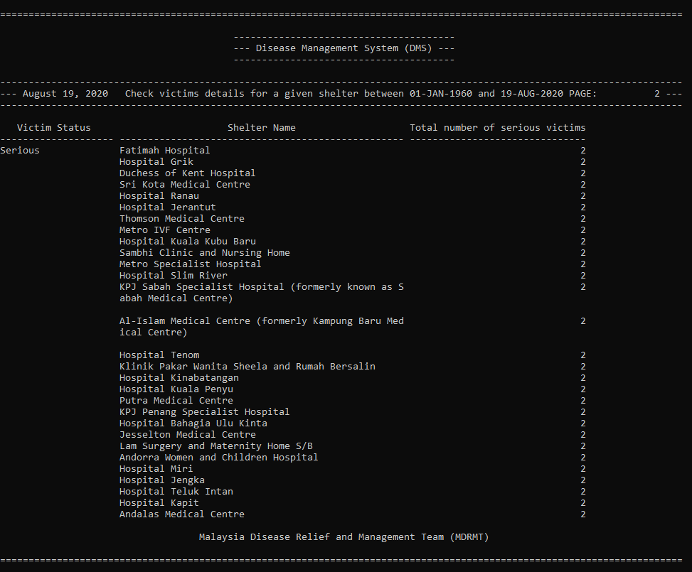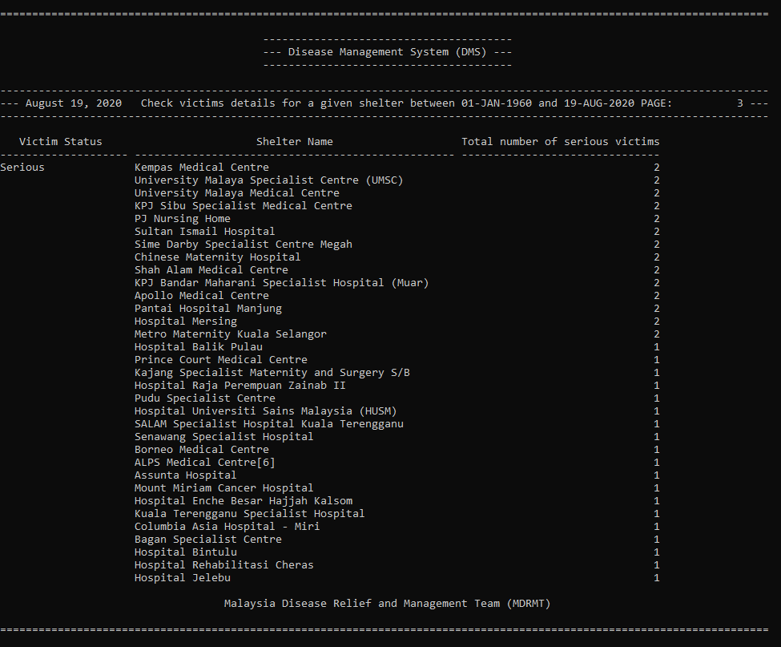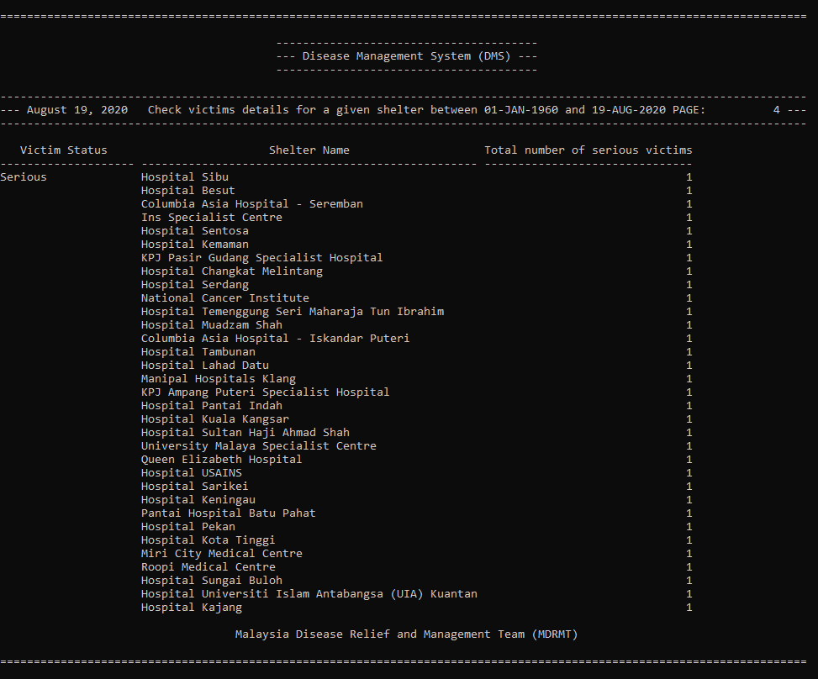
6.1.4 Report 1: Items Stock Report
Purpose: The purpose of this report is to check the numbers of items received through donations between a user defined date.

PL/SQL code:
-- Settings for SQL Plus
SET LINESIZE 120
SET PAGESIZE 50
ALTER SESSION SET NLS_DATE_FORMAT = 'DD-MON-YYYY';

-- Setting current time
SET TERMOUT OFF
BREAK ON TODAY
COLUMN TODAY NEW_VALUE _DATE
SELECT TO_CHAR(SYSDATE, 'fmMonth DD, YYYY') TODAY
FROM DUAL;
CLEAR BREAKS
SET TERMOUT ON
SET VERIFY OFF

-------------------------------------- QUERY 3 -----------------------------------------

-- Taking User Input
PROMPT QUERY 3 - Report of items received through donations between user defined date.
PROMPT
PROMPT Available Items: [Face Mask, Surgical Mask, Blood Bag, Thermometer, Syringe, Rubber gloves, Surgical caps, Bandage, Stethoscopes, Dopplers]
PROMPT (leave blank if all items are needed)
PROMPT
PROMPT Example Start/End Date: 01-MAR-2017
PROMPT
ACCEPT v_start_date CHAR FORMAT A30 PROMPT 'Enter the Start Date: '
ACCEPT v_end_date CHAR FORMAT A30 PROMPT 'Enter the End Date: '
ACCEPT v_item_name CHAR FORMAT A50 PROMPT 'Enter the Item Name(in lowercase): '

-- Setting the Titles
TTITLE CENTER '========================================================================================================================' SKIP 2 -
CENTER '---------------------------------------' SKIP 1 -
CENTER '--- Disease Management System (DMS) ---' SKIP 1 -
CENTER '---------------------------------------' SKIP 2 -
CENTER '------------------------------------------------------------------------------------------------------------------------' SKIP 1 -
LEFT '--- ' _DATE CENTER 'Report of items received through donations between &v_start_date and &v_end_date' RIGHT 'PAGE: ' SQL.PNO ' ---' SKIP 1 -
CENTER '------------------------------------------------------------------------------------------------------------------------' SKIP 2
BTITLE '' SKIP 1 -
CENTER 'Malaysia Disease Relief and Management Team (MDRMT)' SKIP 2 -
CENTER '========================================================================================================================'

-- Formatting the Result
COLUMN item_id FORMAT 9999 HEADING "Item ID" JUSTIFY CENTER
COLUMN name FORMAT A40 HEADING "Item Name" JUSTIFY CENTER
COLUMN TotalNumOfDonation FORMAT 9999 HEADING "Total Numbers of Items" JUSTIFY CENTER

-- Query 3 - Report of items received through donations between user defined date.
SELECT I.item_id, I.name, SUM(DI.quantity_donated) AS TotalNumOfDonation
FROM Donations D, Donation_items DI, Items I
WHERE D.donation_id = DI.donation_id AND DI.item_id = I.item_id
AND D.date_donated BETWEEN TO_DATE('&v_start_date', 'DD-MON-YYYY') AND TO_DATE('&v_end_date', 'DD-MON-YYYY')
AND LOWER(I.name) LIKE '%&v_item_name%'
GROUP BY I.item_id, I.name
ORDER BY TotalNumOfDonation DESC;

CLEAR COLUMNS
TTITLE OFF
BTITLE OFF

Sample Output: 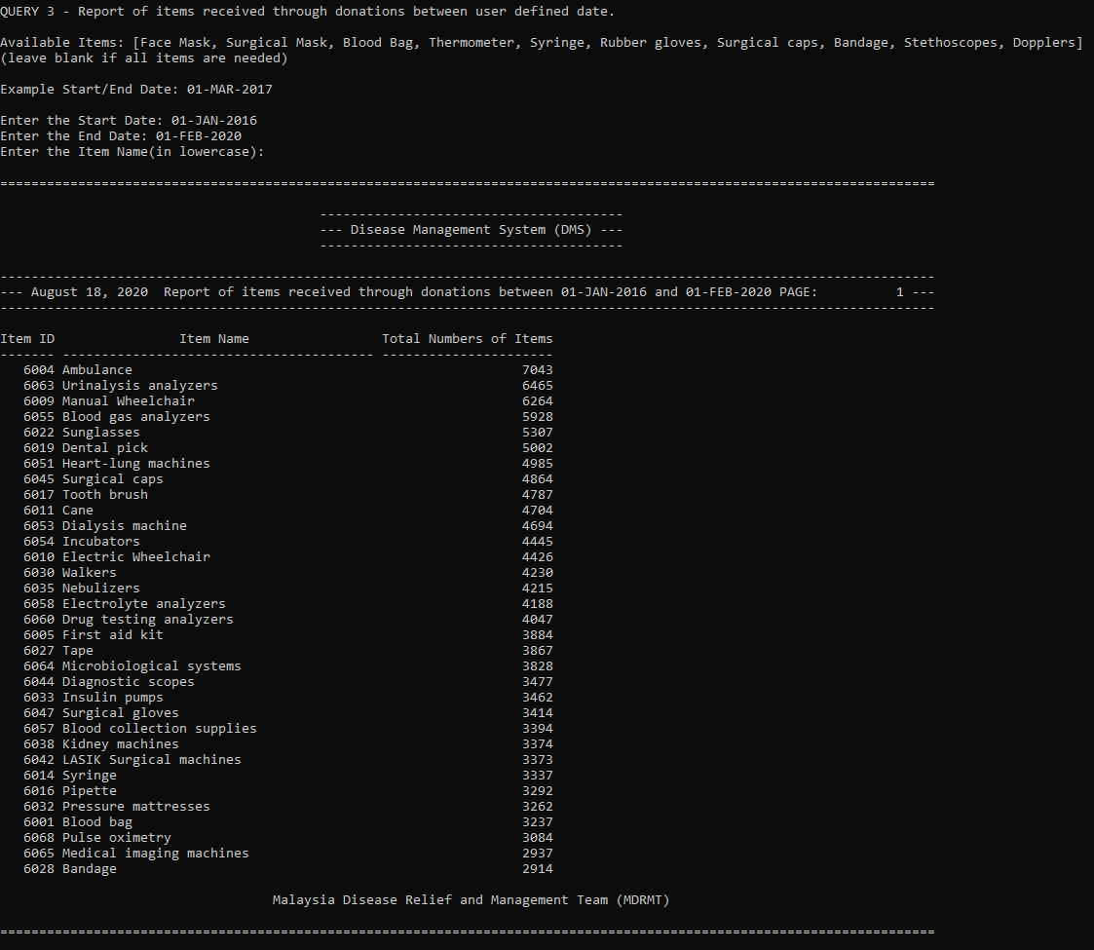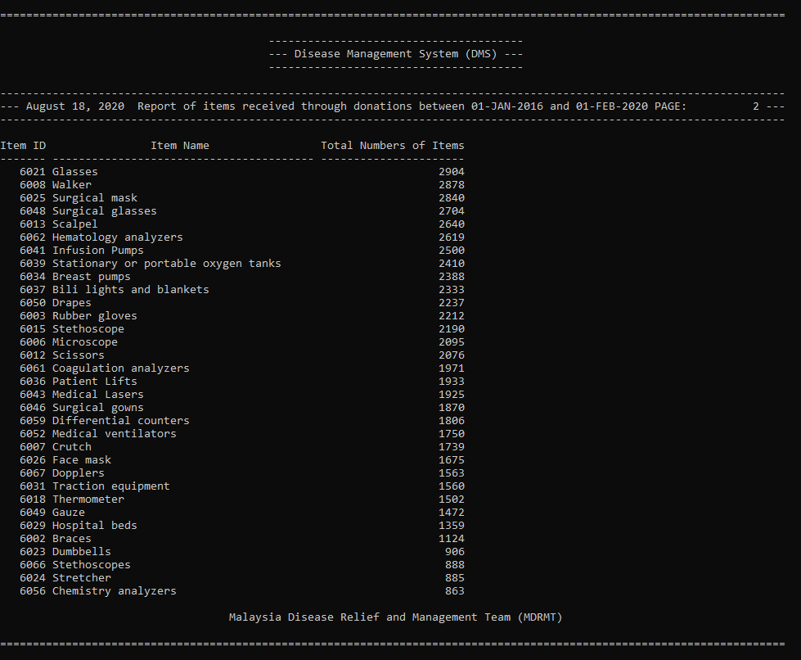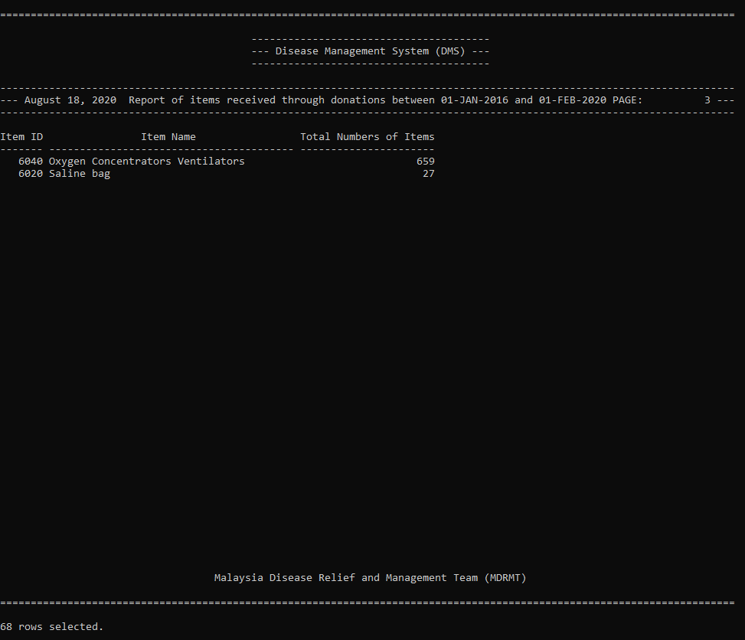
6.1.5 Report 2: Items Allocation Report
Purpose: The purpose of this report is to check the total numbers of items allocated to each shelter between a user defined date.

PL/SQL code:
-- Settings for SQL Plus
SET LINESIZE 120
SET PAGESIZE 50
ALTER SESSION SET NLS_DATE_FORMAT = 'DD-MON-YYYY';

-- Setting current time
SET TERMOUT OFF
BREAK ON TODAY
COLUMN TODAY NEW_VALUE _DATE
SELECT TO_CHAR(SYSDATE, 'fmMonth DD, YYYY') TODAY
FROM DUAL;
CLEAR BREAKS
SET TERMOUT ON
SET VERIFY OFF

-------------------------------------- QUERY 5 -----------------------------------------

-- Taking User Input
PROMPT QUERY 5 - Report of total items allocated to each shelter in a user defined date.
PROMPT
PROMPT Example Start/End Date: 01-MAR-2017
PROMPT
ACCEPT v_start_date CHAR FORMAT A30 PROMPT 'Enter the Start Date: '
ACCEPT v_end_date CHAR FORMAT A30 PROMPT 'Enter the End Date: '

-- Setting the Titles
TTITLE CENTER '========================================================================================================================' SKIP 2 -
CENTER '---------------------------------------' SKIP 1 -
CENTER '--- Disease Management System (DMS) ---' SKIP 1 -
CENTER '---------------------------------------' SKIP 2 -
CENTER '------------------------------------------------------------------------------------------------------------------------' SKIP 1 -
LEFT '--- ' _DATE CENTER 'Total items allocated to each shelter between &v_start_date and &v_end_date' RIGHT 'PAGE: ' SQL.PNO ' ---' SKIP 1 -
CENTER '------------------------------------------------------------------------------------------------------------------------' SKIP 2
BTITLE '' SKIP 1 -
CENTER 'Malaysia Disease Relief and Management Team (MDRMT)' SKIP 2 -
CENTER '========================================================================================================================'

-- Formatting the Result
COLUMN shelter_id FORMAT 9999 HEADING "Shelter ID" JUSTIFY CENTER
COLUMN name FORMAT A50 HEADING "Shelter Name" JUSTIFY CENTER
COLUMN TotalNumOfAllocated FORMAT 9999 HEADING "Total number of items allocated" JUSTIFY CENTER

-- Query 5 - Report of quantity
SELECT S.shelter_id, S.name, SUM(IA.quantity_allocated) AS TotalNumOfAllocated
FROM Items I, Item_allocations IA, Shelters S
WHERE I.item_id = IA.item_id AND IA.shelter_id = S.shelter_id
AND IA.date_allocated BETWEEN TO_DATE('&v_start_date', 'DD-MON-YYYY') AND TO_DATE('&v_end_date', 'DD-MON-YYYY')
GROUP BY S.shelter_id, S.name
ORDER BY TotalNumOfAllocated DESC;

CLEAR COLUMNS
TTITLE OFF
BTITLE OFF

Sample Output:
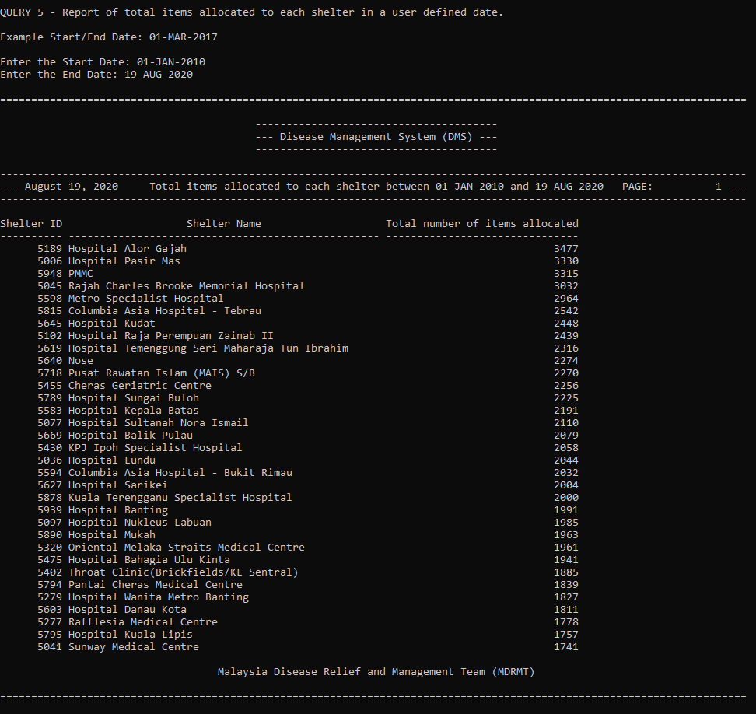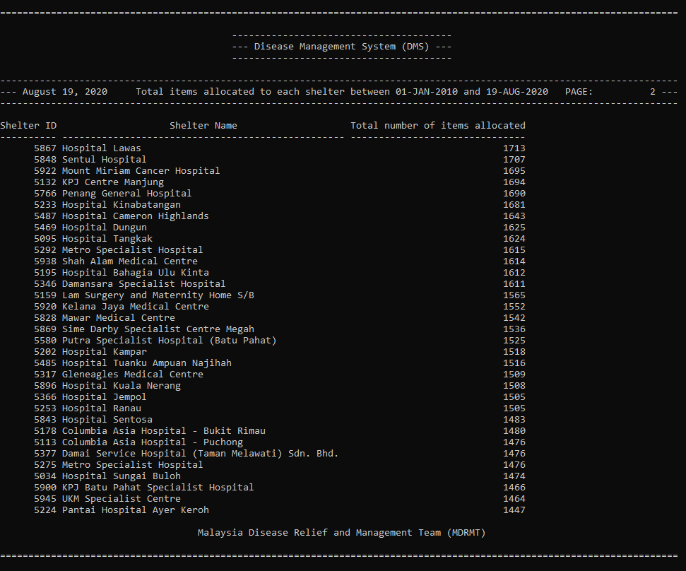

Task 7: Extra Effort Highlights

7.1 Lee Kai Yang
7.1.1 PL/SQL Block
Description: There are five PL/SQL Blocks in the script file, each block is used for a different purpose. For example, drop tables, prompt users, verify records inserted.
Purpose: They are to accept user input and execute SQL statements dynamically.

SQL Code:
-- Settings for PL/SQL
SET serveroutput ON -- Turning on the output for printing info from PL/SQL
SET VERIFY OFF -- Turn off the verification for PL/SQL
WHENEVER SQLERROR EXIT SQL.SQLCODE ROLLBACK; -- Exit the script execution whenever an exception is raised

-- Startup Screen for Users
cl scr
PROMPT Welcome to DBMS of Disease Management System (DMS)
PROMPT

----------------------------
-- SECTION 1: DROP TABLES --
----------------------------

-- Prompt Users whether to drop tables
ACCEPT dropTable CHAR PROMPT 'Do you want to drop the tables? (Y/N): '

-- PL/SQL 1
DECLARE
type tablesarray IS VARRAY(14) OF VARCHAR(30);
tables tablesarray;
total integer;
nCount integer;
successCount integer;
dropTable char;
BEGIN
-- Assigning user input
dropTable := '&dropTable';

-- Assigning tables names to the array
tables := tablesarray('diseases', 'victims', 'staffs', 'donors', 'shelters', 'items', 'tasks', 'disease_identifications', 'exam_allocations', 'workload', 'donations', 'donation_items', 'shelter_allocations', 'item_allocations');
total := tables.count;
successCount := 0;

-- Enabling DBMS_OUTPUT package
DBMS_OUTPUT.ENABLE;

-- If User input 'Y' or 'y' then drop tables
IF UPPER(dropTable) = 'Y' THEN
-- Looping through the array
FOR i in REVERSE 1 .. total LOOP -- Droping tables from the back
SELECT COUNT(*) INTO nCount FROM user_tables WHERE LOWER(table_name) LIKE (tables(i)); -- Put the count of table into nCount

IF (nCount > 0) THEN -- If nCount > 0 then table exist
EXECUTE IMMEDIATE 'DROP TABLE ' || tables(i); -- Drop the table
DBMS_OUTPUT.PUT_LINE('[SUCCESS] (' || tables(i) || ') is dropped.');
successCount := successCount + 1;
END IF;
END LOOP;

EXECUTE IMMEDIATE 'DROP SEQUENCE disease_id_seq';
EXECUTE IMMEDIATE 'DROP SEQUENCE victim_id_seq';
EXECUTE IMMEDIATE 'DROP SEQUENCE staff_id_seq';
EXECUTE IMMEDIATE 'DROP SEQUENCE donor_id_seq';
EXECUTE IMMEDIATE 'DROP SEQUENCE shelter_id_seq';
EXECUTE IMMEDIATE 'DROP SEQUENCE item_id_seq';
EXECUTE IMMEDIATE 'DROP SEQUENCE task_id_seq';
EXECUTE IMMEDIATE 'DROP SEQUENCE donation_id_seq';
END IF;

-- Printing the summary
DBMS_OUTPUT.PUT_LINE(chr(13));
DBMS_OUTPUT.PUT_LINE(successCount || '/' || total || ' tables are successfully dropped. (' || round((successCount/total)*100, 2) || '%)');
DBMS_OUTPUT.NEW_LINE();
END;
/

ACCEPT continue CHAR PROMPT 'Continue? (Y/N): '

-- PL/SQL 2
DECLARE
continue char;
BEGIN
-- Assign user input to variable
continue := '&continue';

IF UPPER(continue) = 'Y' THEN
-- Show Users tables to be created
DBMS_OUTPUT.PUT_LINE(chr(13));
DBMS_OUTPUT.PUT_LINE('Below are the tables that will be created');
DBMS_OUTPUT.PUT_LINE('------------------------------------------');
DBMS_OUTPUT.PUT_LINE('1. diseases');
DBMS_OUTPUT.PUT_LINE('2. victims');
DBMS_OUTPUT.PUT_LINE('3. staffs');
DBMS_OUTPUT.PUT_LINE('4. donors');
DBMS_OUTPUT.PUT_LINE('5. shelters');
DBMS_OUTPUT.PUT_LINE('6. items');
DBMS_OUTPUT.PUT_LINE('7. tasks');
DBMS_OUTPUT.PUT_LINE('8. disease_identifications');
DBMS_OUTPUT.PUT_LINE('9. exam_allocations');
DBMS_OUTPUT.PUT_LINE('10. workload');
DBMS_OUTPUT.PUT_LINE('11. donations');
DBMS_OUTPUT.PUT_LINE('12. donation_items');
DBMS_OUTPUT.PUT_LINE('13. shelter_allocations');
DBMS_OUTPUT.PUT_LINE('14. item_allocations');
ELSE
-- Exit if user doesn't input 'Y' or 'y'
DBMS_OUTPUT.PUT_LINE('Okay, Good Bye!');
RAISE_APPLICATION_ERROR(-20000, 'User Exited');
END IF;
END;
/

-- … CREATE TABLES…

-----------------------------
-- SECTION 3: CHECK TABLES --
-----------------------------
DECLARE
type tablesarray IS VARRAY(14) OF VARCHAR(30);
tables tablesarray;
total integer;
nCount integer;
successCount integer;
BEGIN
-- Assigning tables names to the array
tables := tablesarray('diseases', 'victims', 'staffs', 'donors', 'shelters', 'items', 'tasks', 'disease_identifications', 'exam_allocations', 'workload', 'donations', 'donation_items', 'shelter_allocations', 'item_allocations');
total := tables.count;
successCount := 0;

-- Enabling DBMS_OUTPUT package
DBMS_OUTPUT.ENABLE;

-- Printing info screen
DBMS_OUTPUT.PUT_LINE('Disease Management System (DMS) of Malaysia Disease Relief and Management Team (MDRMT)');
DBMS_OUTPUT.PUT_LINE(chr(13));

-- Looping through the array
FOR i in 1 .. total LOOP
SELECT COUNT(*) INTO nCount FROM user_tables WHERE LOWER(table_name) LIKE (tables(i)); -- Put the count of table into nCount

IF (nCount <= 0) THEN -- If nCount <= 0 then table doesn't exist
DBMS_OUTPUT.PUT_LINE('[FAILED] (' || tables(i) || ') is not created.');
ELSE
DBMS_OUTPUT.PUT_LINE('[SUCCESS] (' || tables(i) || ') is created.');
successCount := successCount + 1;
END IF;
END LOOP;

-- Printing the summary
DBMS_OUTPUT.PUT_LINE(chr(13));
DBMS_OUTPUT.PUT_LINE(successCount || '/' || total || ' tables are successfully created. (' || round((successCount/total)*100, 2) || '%)');
END;
/

-------------------------------
-- SECTION 4: INSERT RECORDS --
-------------------------------
ACCEPT insertRecord CHAR PROMPT 'Do you want to insert sample records? (Y/N): '

DECLARE
insertRecord char;
BEGIN
-- Assigning user input to variable
insertRecord := '&insertRecord';

-- Enabling DBMS_OUTPUT package
DBMS_OUTPUT.ENABLE;

IF UPPER(insertRecord) != 'Y' THEN
DBMS_OUTPUT.PUT_LINE('No records are inserted');
DBMS_OUTPUT.PUT_LINE('Okay, Good Bye!');
RAISE_APPLICATION_ERROR(-20000, 'User Exited');
END IF;
END;
/
-- INSERT RECORDS

-------------------------------
-- SECTION 5: VERIFY RECORDS --
-------------------------------
-- PL/SQL 4
DECLARE
type tablesarray IS VARRAY(14) OF VARCHAR(30);
tables tablesarray;
nCount integer;
totalRecord integer;
BEGIN
-- Assigning tables names to the array
tables := tablesarray('diseases', 'victims', 'staffs', 'donors', 'shelters', 'items', 'tasks', 'disease_identifications', 'exam_allocations', 'workload', 'donations', 'donation_items', 'shelter_allocations', 'item_allocations');
totalRecord := 0;

-- Enabling DBMS_OUTPUT package
DBMS_OUTPUT.ENABLE;

-- Looping through the array
FOR i in 1 .. tables.count LOOP
-- Select the row counts into nCount
EXECUTE IMMEDIATE 'SELECT COUNT(*) FROM ' || tables(i) || '' INTO nCount;

IF (nCount > 0) THEN
DBMS_OUTPUT.PUT_LINE('[Success] ' || nCount || ' records are inserted into ' || tables(i) || '.');
totalRecord := totalRecord + nCount;
END IF;
END LOOP;

-- Printing the summary
DBMS_OUTPUT.PUT_LINE(chr(13));
DBMS_OUTPUT.PUT_LINE('A total of ' || totalRecord || ' records are successfully inserted.');
DBMS_OUTPUT.NEW_LINE();
END;
/

7.1.2 Sequences and Triggers
Description: Sequences and triggers are added wherever the table has an ID attribute.
Purpose: They are used to auto-increment the ID whenever a record is inserted. This will greatly reduce the effort needed to insert large amount of records.

SQL Code:
…

CREATE TABLE diseases (
disease_id NUMBER, -- PK
name VARCHAR(100) NOT NULL UNIQUE,
type VARCHAR(30),
description VARCHAR(255),
PRIMARY KEY(disease_id)
);

-- Following code is to auto-increment disease_id

-- This sequence is to auto increment the id.
CREATE SEQUENCE disease_id_seq START WITH 1001;

-- Below code is to trigger sequence to increment by 1 when CREATE or REPLACE is detected.
CREATE OR REPLACE TRIGGER disease_id_bir
BEFORE INSERT ON diseases
FOR EACH ROW

BEGIN
SELECT disease_id_seq.NEXTVAL
INTO :new.disease_id
FROM dual;
END;
/

…

7.1.3 Constraints
Description: Constraints are added to tables that has attribute that needs to be validated.
Purpose: They are used to validate data when a record is inserted or a record is to be updated. This will help prevent invalid data during record insertion or update.

SQL Code:
…

CREATE TABLE staffs (
staff_id NUMBER, -- PK
name VARCHAR(255) NOT NULL,
gender CHAR(1) NOT NULL,
race VARCHAR(12) NOT NULL,
ic_num VARCHAR(15) NOT NULL UNIQUE, -- IC Number must be specified and cannot be duplicated
birth_date DATE NOT NULL,
phone_num VARCHAR(15) NOT NULL UNIQUE, -- Phone Number must be specified and cannot be duplicated
email VARCHAR(50) NOT NULL UNIQUE, -- Email must be specified and cannot be duplicated
address VARCHAR(255) NOT NULL,
position VARCHAR(30) NOT NULL,
kpi NUMBER(3,2) DEFAULT 2.00, -- Default to 2.00 if not specified
PRIMARY KEY(staff_id),
CONSTRAINT chk_staff_gender CHECK (UPPER(gender) in ('M', 'F')),
CONSTRAINT chk_staff_race CHECK (UPPER(race) in ('CHINESE', 'MALAY', 'INDIAN', 'IBAN', 'KADAZANDUSUN', 'OTHERS')),
CONSTRAINT chk_staff_email CHECK (REGEXP_LIKE(email,'^[a-zA-Z]\w+@(\S+)$'))
);

…

